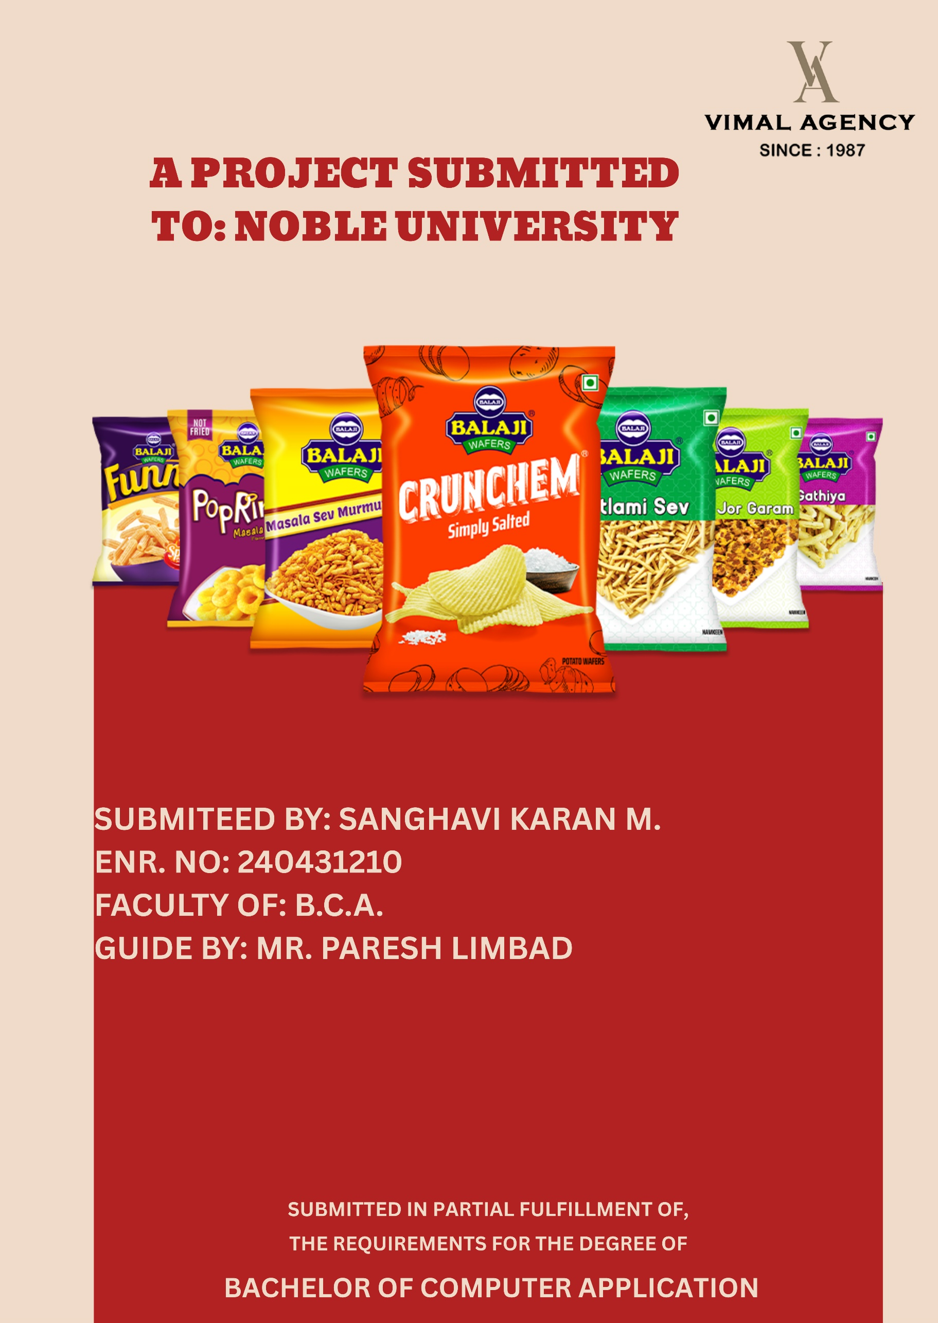
Vimal Agency

A PROJECT REPORT
Submitted to


Noble University, Junagadh
Fir Practical requirement fulfilment in
BCA Semester – 5

Prepared by
Karan Sanghavi
Enrolment No. 240431210

Guided by
Mr. Paresh Limbad

NOBLE BCA COLLAGE,
NOBLE UNIVERSITY – JUNAGADH



Noble University, Junagadh

Certificate
Enrollment No:

This is to certify that the Project / Practical work was satisfactorily carried out and the report submitted herewith is the bonafide work of Mr. Karan Sanghavi student of Bachelor of Computer Applications (BCA) Semester V, in the Laboratory of Noble University, Junagadh, during the academic year 2026–27.

Internal Guide Principal
_____________ ______________

Preface
This report contains all the outputs of a project undertaken to develop a working model of Vimal Agency and to study the existing working system. As part of this study, we analysed the requirements of the working model and tried to improve it using the technological functionality that the current computer science provides.

This volume contains the documentation summary of the working system, the background study and analysis, the technical requirements and the working specification of the developed system.

We recommend the user to take the advantage of the study presented here and implement the system with their required improvisation. We hope this study will reduce the burden of the reanalysis of the development phase.

Acknowledgment

“It is not possible to prepare a project report without the assistance & encouragement of other people. This one is certainly no exception.”

On the very outset of this report, we would like to extend our sincere & heartfelt obligation towards all the personages who have helped us in this endeavour. Without their active guidance, help, cooperation & encouragement, we would not have made headway in the project. We are ineffably indebted to our Dean, Mr. Paresh Vora Sir for his conscientious guidance and encouragement to accomplish this assignment.

We are extremely thankful and pay our gratitude to our project guide Prof Mr. Paresh Limbad valuable guidance and support on completion of this project in its presently.

We extend our gratitude to Faculty of Computer Application, Noble University, Junagadh for giving us this opportunity.

Thanking You

Karan Sanghavi
240431210

Table of Content
Sr. No. | Title |  |  | Page No.
1 | University Certificate |  |  | -
2 | Preface |  |  | -
3 | Acknowledgement |  |  | -
4 | Introduction |  |  | 1-3
5 | Project Profile |  |  | 3
 | 1.1 | Definition |  | 4
 | 1.2 | Scope |  | 5
 | 1.3 | Objective |  | 6
6 | Student Profile |  |  | 7-8
 | Student Name, Enrolment No, Department |  |  | 8
7 | System Analysis and Specification |  |  | 9-14
 | 2.1 | Existing System |  | 10
 | 2.2 | Limitations of Existing System |  | 11
 | 2.3 | Feasibility Study |  | 12
 | 2.4 | Need of New System |  | 13
 | 2.5 | Front End & Back End Tools |  | 14
8 | System Requirement Specification |  |  | 15-19
 | 3.1 | Proposed System and Advantages |  | 16-17
 | 3.2 | Development Strategy Model |  | 18-19
9 | System Design |  |  | 20-49
 | 4.1 | Data Flow Diagram |  | 21-22
 | 4.2 | E-R Diagram |  | 23-25
 | 4.3 | Class Diagram |  | 26-32
 | 4.4 | Use Case Diagram |  | 33-35
 | 4.5 | Sequence Diagram |  | 36-38
 | 4.6 | Activity Diagram |  | 39-41
 | 4.7 | Data Dictionary |  | 42-49
10 | System Screen Design |  |  | 50-107
 | 5.1 | User View Design |  | 51-82
 |  | 1 | Login Page | 51-52
 |  | 2 | Register Page | 53-54
 |  | 3 | Index Page | 55-58
 |  | 4 | Product Page | 59-63
 |  | 5 | Feedback Page | 64-66
 |  | 6 | About Us Page | 67-70
 |  | 7 | Contact Us Page | 71-73
 |  | 8 | Cart Page | 74-76
 |  | 9 | Checkout Page | 77-79
 |  | 10 | Order History Page | 80-82
 | 5.2 | Admin View Design |  | 83-111
 |  | 1 | Admin Login Page | 83-85
 |  | 2 | Admin Dashboard Page | 86-88
 |  | 3 | Manage Product Page | 89-93
 |  | 4 | Manage User Order Page | 94-96
 |  | 5 | Manage Offer Page | 97-99
 |  | 6 | Manage Promos Page | 100-102
 |  | 7 | Manage User Page | 103-105
 |  | 8 | Manage User Feedback Page | 106-108
 |  | 9 | Manage Contact Lead Page | 109-111
11 | Coding (Few Code Snippets) |  |  | 112-115
12 | Testing (Manual, Test Cases) |  |  | 116-118
 | 6.1 | Manual Testing |  | 117
 | 6.2 | Test Cases |  | 118
13 | Enhancements |  |  | 119-122
 | 7.1 | Advantages of Your Project |  | 120
 | 7.2 | Limitation of Your Project |  | 121
 | 7.3 | Future Scope |  | 122
14 | References |  |  | 123

INTRODUCTION
1. Introduction:


Vimal Agency

Vimal Agency has been a prominent name in the FMCG distribution sector since 1987. Specializing in snacks and namkeen, they hold the prestige of being the first-ever distributor of Balaji Wafers.

With a legacy spanning over three decades, Vimal Agency has built a widespread network of 700+ customers across Junagadh. Their commitment to excellence and long-standing partnership with Balaji Wafers makes them a trusted leader in the local market.

PROJECT PROFILE

1.1 Definition:

Vimal Agency: Strategic FMCG Distribution & Market Leadership
Vimal Agency stands as a cornerstone of the FMCG (Fast-Moving Consumer Goods) landscape in Junagadh, Gujarat. Operating as a high-velocity distribution enterprise, the agency has transitioned from a traditional trading firm into a sophisticated Supply Chain Management (SCM) hub, specifically optimized for the snacks and namkeen sector.

Core Operational Pillars
- Integrated Supply Chain Excellence: Vimal Agency functions as the critical intermediary between large-scale manufacturing units and the fragmented retail market. By implementing systematic procurement and inventory turnover strategies, the agency ensures a seamless flow of goods, minimizing stock-outs and maximizing product freshness.
- Hyper-Local Distribution Network: With a deep-rooted presence in Junagadh and surrounding regions, the agency manages an extensive network of retail partners, ranging from modern supermarkets to traditional kirana stores. This reach provides brands with unparalleled market penetration in both urban and rural pockets.
- Advanced Logistics & Warehousing: The agency utilizes structured warehousing protocols to maintain the quality and shelf-life of food products. Their logistics framework is designed for agility, ensuring that high-demand snacks reach the end-consumer through an organized, time-sensitive delivery system.
- Market Intelligence & Brand Representation: Beyond logistics, Vimal Agency acts as a brand custodian. By analyzing local consumer behavior and demand trends, they provide valuable feedback to manufacturers, helping to align product supply with the evolving tastes of the Saurashtra region.

Value Proposition
- Reliability & Legacy: Built on a foundation of trust, Vimal Agency is recognized for its ethical business practices and long-standing relationships with vendors.
- Scalability: The agency’s infrastructure is designed to handle large-scale volume shifts, making it an ideal partner for brands looking to scale their operations in Gujarat.
- Efficiency: Through optimized route planning and digital inventory tracking, the agency maintains a competitive edge in operational cost and speed.

1.2 Scope:
The operational framework of Vimal Agency is built on a foundation of regional dominance and a deeply entrenched distribution network:
- Market Legacy & Dominance: As the first and oldest authorized distributor for Balaji Wafers, Vimal Agency holds a prestigious position in the FMCG sector. With a legacy spanning over three decades (since 1987), the agency has been instrumental in establishing brand loyalty and market share within the region.
- Geographical Footprint: The agency operates a robust logistics infrastructure that provides comprehensive coverage across the entire Junagadh district. This includes high-frequency distribution to major urban centers as well as consistent penetration into interior rural pockets.
- Extensive Client Network: Vimal Agency actively manages a diverse B2B portfolio of 700+ retail touchpoints. This network comprises a wide spectrum of businesses, including modern supermarkets, established provision stores, and small-scale local vendors.
- End-to-End Logistics & Infrastructure: The core of the agency’s success lies in its high-velocity operations, featuring:
  - Inventory Management: Real-time tracking and daily stock replenishment to ensure product freshness.
  - Order Fulfillment: A streamlined process for high-volume order intake and rapid processing.
  - Last-Mile Delivery: A dedicated fleet of delivery vehicles ensuring timely and reliable distribution to every retail partner.

1.3 Objective:

The core mission of Vimal Agency is centered on three pillars: Scalability, Reliability, and Service Excellence. The agency’s strategic goals are defined as follows:
- Operational Excellence & Supply Chain Stability: To maintain a seamless and time-sensitive supply chain that ensures 100% product availability. By optimizing logistics, the agency aims to eliminate "stock-out" scenarios, ensuring that retail partners always have access to fresh inventory.
- Brand Advocacy & Market Expansion: To serve as a proactive growth partner for brands like Balaji Wafers. This involves the strategic rollout of new product lines, maximizing shelf visibility, and executing localized marketing strategies to strengthen brand equity in the Junagadh region.
- Retailer-Centric Ecosystem: To foster long-term, transparent professional relationships with a diverse network of over 700 retailers. This is achieved through a commitment to fair pricing models, consistent support, and a trust-based "Customer First" philosophy.
- Digital Transformation & Modernization: A key strategic priority is the transition from legacy distribution methods to an Integrated Management Information System (MIS). This modernization focuses on:
  - Automated Sales Tracking: Real-time monitoring of market demand.
  - Inventory Optimization: Reducing waste and ensuring efficient stock rotation.
  - Employee Performance Management: Utilizing data-driven insights to streamline staff workflows and productivity.

STUDENT PROFILE

- Project on: - Vimal Agency

- Developed by: - Karan Sanghavi

- Semester: - BCA 5th Sem.

- Guidance by: - Mr. Paresh Limbad

- Technology: - JSP, Bootstrap

- Platform: - Windows

- Submitted to: - Noble University.

SYSTEM ANALYSIS AND SPECIFICATION

2.1 Existing System
The current operations of Vimal Agency are primarily manual and traditional. Despite managing a vast network in Junagadh, most business processes, from order procurement to final delivery, rely on physical records and verbal communication.
Key Features of the Existing System:
- Manual Order Procurement: Orders from the 700+ retail touchpoints are typically collected via phone calls or recorded in physical diaries by field sales representatives during site visits.
- Paper-Based Inventory Tracking: The stock of Balaji Wafers and other namkeen products is monitored through manual ledger entries, which often leads to a lag between physical stock and recorded data.
- Traditional Customer Management: Records of retailers, including their credit history and contact details, are maintained in physical registers or basic lists.
- Physical Billing: Invoices are often handwritten or generated through basic, non-integrated software, making payment tracking a labor-intensive process.
- Manual Route Planning: Delivery schedules and vehicle loading are planned based on human memory and experience rather than data-driven route optimization.

2.2 Limitations of Existing System
- High Risk of Human Error: Manual order entry frequently leads to mistakes in quantities or product variants, resulting in returned goods and loss of revenue.
- Inaccurate Inventory Visibility: Lack of real-time tracking often causes "stock-out" scenarios for high-demand products or overstocking of slow-moving items.
- Data Fragmentation: Information regarding sales, employees, and inventory is stored in separate physical files, making it impossible to get a unified view of the business.
- Inefficient Communication: Coordinating between the warehouse, the 700+ retailers, and the delivery staff is slow and prone to miscommunication.
- Lack of Real-time Reporting: Generating sales trends or employee performance reports is a slow, manual process, hindering quick decision-making.
- Poor Data Security: Physical records are vulnerable to damage, loss, or unauthorized access.
- Limited Scalability: The manual system cannot efficiently support the agency's goals for further expansion or modernized e-commerce integration.

2.3 Feasibility Study
A feasibility study was conducted to ensure that the proposed digital system is viable for Vimal Agency’s specific market environment.
- Technical Feasibility: Developing a web-based management system using Java/JSP and MySQL is highly feasible. The infrastructure required (servers and mobile devices for staff) is readily available and easy to maintain.
- Economic Feasibility: The initial investment in developing the Vimal Agency Management System is justified by the significant reduction in manual errors, optimized fuel costs for delivery, and improved labor productivity.
- Operational Feasibility: The system is designed with a user-friendly interface to ensure that staff members, regardless of their technical background, can transition from paper to digital records with minimal training.
- Schedule Feasibility: The project follows a structured timeline, allowing for module-wise development, testing, and deployment without disrupting the agency's daily supply chain operations.

2.4 Need of New System
The transition from a manual to a computerized system is essential for Vimal Agency to maintain its market dominance in Junagadh. The new system is required to:
- Automate the Supply Chain: Streamline everything from order placement to last-mile delivery.
- Enable E-commerce for Retailers: Provide a 24/7 digital platform where 700+ retailers can place orders, view product availability, and track their order status independently.
- Enhance Accuracy: Eliminate discrepancies in billing and inventory through a centralized database.
- Improve Employee Accountability: Track field staff performance and attendance through a dedicated management module.
- Provide Data Insights: Use automated reporting to understand market demands and optimize product stocking.

2.5 Front End & Back End Tools

1. Front-End Tools
The user interface is designed to be clean and professional, focusing on high functionality and ease of use.
- HTML5: Used for structuring the web pages and the e-commerce storefront.
- CSS3: For styling and ensuring a modern look. As per branding requirements, the design is minimalist (e.g., the heart icon has been removed from the footer).
- JavaScript: For client-side validation and interactive elements such as dynamic order status updates.
- Responsive Web Design: Ensures the system is fully accessible on both office desktops and field-staff smartphones.

2. Back-End Tools
The back-end architecture ensures data integrity and secure processing of high-volume transactions.
- Programming Language (JSP/Java): Handles the core business logic, user authentication, and server-side processing. All code comments and documentation are maintained strictly in English.
- Database (MySQL): A robust relational database management system used to store data for 700+ retailers, product catalogs, and employee records.
- Server (Apache Tomcat): Acts as the web server and servlet container for the JSP application.
- JDBC (Java Database Connectivity): Facilitates seamless communication between the Java application and the MySQL database.

SYSTEM REQUIREMENT SPECIFICATION

3.1 Proposed System and Advantages
The proposed system for Vimal Agency is a comprehensive, computerized, and integrated management platform designed to digitize the distribution of snacks and namkeen. This system will automate the workflow between the agency and its 700+ retail partners, moving from manual ledgers to a real-time digital environment. It enables retailers to browse the product catalog of brands like Balaji Wafers, place orders, and track their delivery status through a secure web interface.
Key features of the proposed system include:
- Automated Order Management: Capturing bulk orders from retailers accurately and eliminating the errors associated with manual phone-based ordering.
- Real-time Inventory Control: Digital monitoring of snacks and namkeen stock levels to ensure "Just-in-Time" replenishment and prevent "out-of-stock" scenarios.
- Retailer Relationship Management (RRM): Maintaining detailed profiles of 700+ retail touchpoints, including order history and route preferences for personalized service.
- Digital Billing and Payment: Automatic generation of digital invoices and tracking of payment statuses to maintain transparent financial records.
- Last-Mile Delivery Tracking: Monitoring the delivery fleet to ensure timely distribution across the Junagadh district.
- Sales Analytics & Reporting: Generating detailed performance reports for various product lines and tracking the productivity of field staff.
Advantages of the Proposed System:
- Operational Efficiency: Automation significantly reduces the time spent on manual data entry and logistics planning.
- Data Accuracy: Minimizes human error in order processing, stock counting, and financial accounting.
- 24/7 Accessibility: Retailers can place orders at any time through the e-commerce portal, not just during business hours.
- Enhanced Inventory Turnover: Real-time tracking ensures that fresh products are prioritized for delivery, reducing waste.
- Business Scalability: The system is built to support future growth as the agency expands its brand portfolio or geographical reach.
- Improved Professionalism: Moving to a digital platform enhances the agency's reputation among top-tier brands and modern retailers.
- Better Data Security: Digital records are protected via role-based access, preventing the loss or damage common with paper files.

3.2 Development Strategy Model
The development of the Vimal Agency Management System follows the Software Development Life Cycle (SDLC) to ensure the final product is robust, secure, and meets all distribution requirements.
1. Requirement Analysis: Identifying the specific needs of the agency, such as the ability to handle high-volume bulk orders, tracking 700+ different delivery points, and managing a large inventory of perishable snacks.
2. System Design: Designing the system architecture, including the JSP-based backend, MySQL database schema, and a Mobile-First frontend for retailers and field staff.
3. Development (Coding):
- Frontend Development: Creating a clean, minimalist user interface using HTML, CSS, and JavaScript. As per user instructions, the interface is professional and excludes unnecessary decorative icons [cite: 2026-02-13].
- Backend Development: Building the server-side logic using Java (JSP/Servlets) to handle order processing and secure login [cite: 2026-02-16]. All code comments are written in English [cite: 2026-02-16].
- Database Development: Constructing a relational database in MySQL to store complex data tables for retailers, products, orders, and employees.
4. Testing: Rigorous testing of order flows, payment tracking, and inventory updates to ensure the system is reliable for daily business operations.
5. Implementation: Deploying the system on an Apache Tomcat server, allowing both administrative staff and external retailers to access their respective modules.
6. Maintenance & Updates: Providing ongoing support to update product catalogs, manage new retail partners, and refine the distribution algorithms based on performance data.
Development Model Used: For Vimal Agency, the Incremental Development Model is utilized:
- Increment 1: Core Employee Management System and attendance tracking [cite: 2026-02-13].
- Increment 2: Product catalog and basic ordering for retailers.
- Increment 3: Advanced inventory management and billing integration.
- Increment 4: Full analytics dashboard and route optimization.
Advantages of this Strategy:
- Phased Rollout: Allows the agency to adapt to one module at a time without overwhelming the staff.
- Early Feedback: Testing the employee module first allows for adjustments before launching the retailer-facing e-commerce portal.
- Reduced Risk: Smaller, manageable updates reduce the chance of system-wide downtime.

SYSTEM DESIGN

4.1 Data Flow Diagram

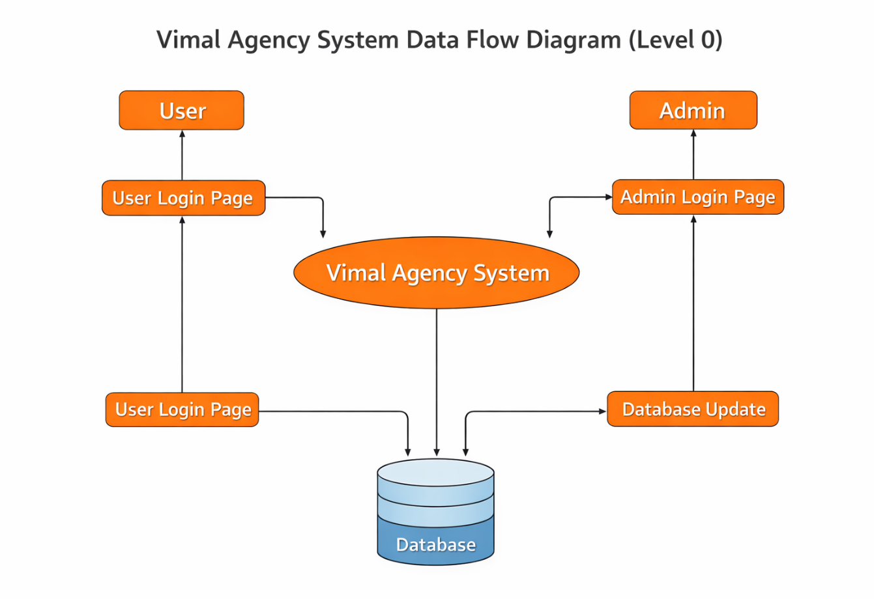

Description
The diagram represents the interaction between the User, the Vimal Agency system, and the Admin.
• User: The customer who interacts with Vimal Agency by browsing products, placing orders, applying promo codes, and making payments through Cash on Delivery. The user sends requests to the system and receives services such as order confirmation and delivery status.
• Vimal Agency System: The central component that processes all requests. It acts as a bridge between the user and the admin. It manages order processing, promo code validation, payment handling (COD), and communication between both sides.
• Admin: The administrator manages the backend operations. The admin updates products, confirms and processes orders, manages customer data, creates offers and promo codes, and updates order status. The admin’s interaction ensures smooth functioning and accurate service delivery through the Vimal Agency system.

Flow of Interaction
• The User sends input (order details, promo code, payments) to the system.
• The System (Vimal Agency) processes the request and forwards necessary information to the Admin.
• The Admin validates, manages, and updates the system, while the system communicates back to the User with order confirmations and status updates.

4.2 E-R Diagram

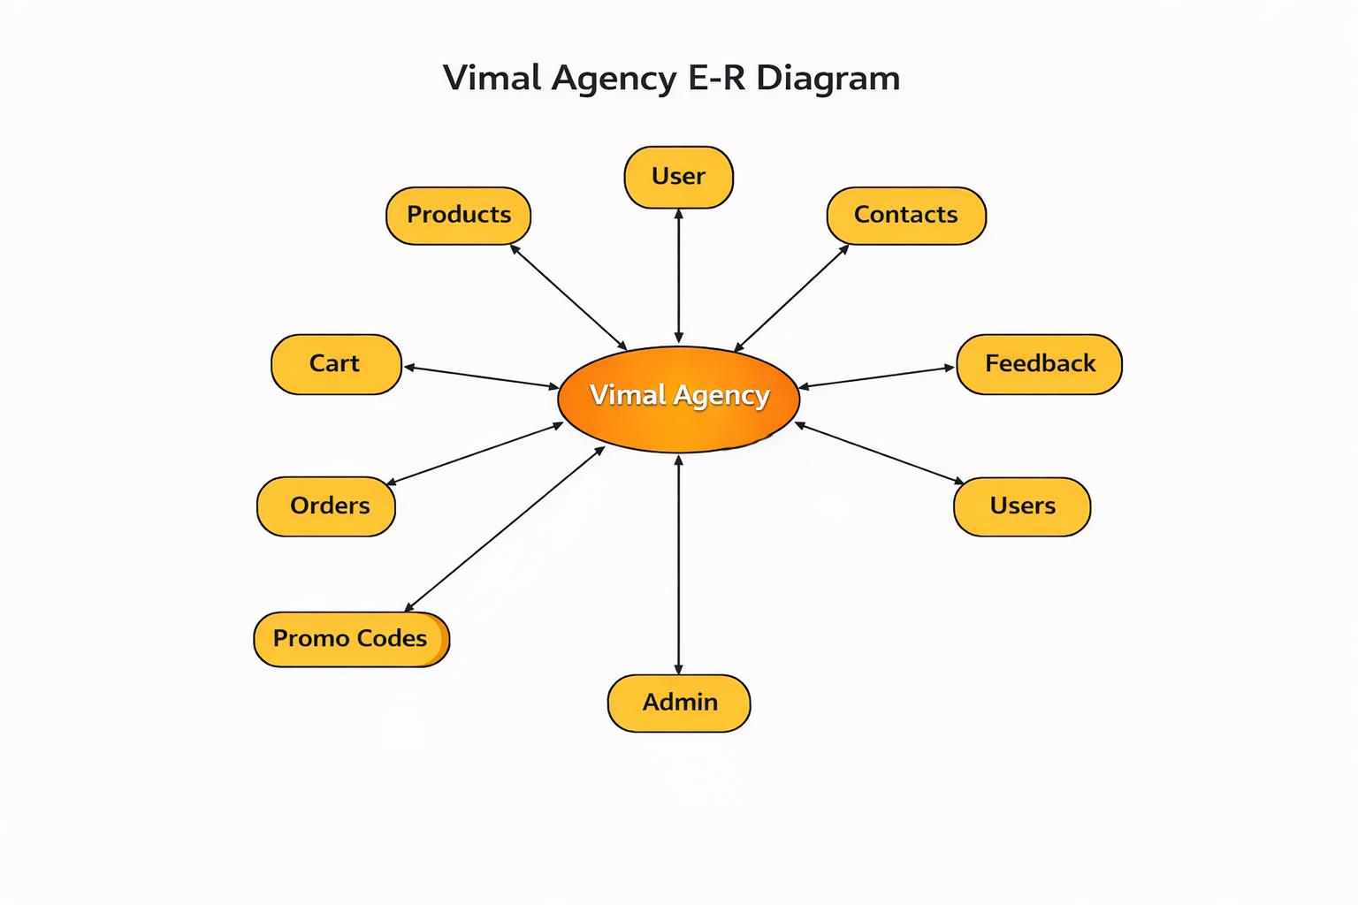

1. User
The customer or end-user interacts with the system through the following processes:
• Browse Products → Users can view available products with details and pricing.
• Add to Cart → Users can select products and add them to their shopping cart.
• Place Order → Users can confirm and place orders for selected products.
• Make Payment → Users can complete payment through available payment methods.
• Apply Promo Code → Users can apply discount codes while placing an order.
• Give Feedback → After receiving products, users can provide reviews or feedback.
• Contact Us → Users can send inquiries, complaints, or support requests.

2. Admin
The administrator manages the backend operations of Vimal Agency:
• Add / Update Products → Admin uploads product details, pricing, and descriptions.
• Manage Users → Admin can view and manage registered users.
• View Orders → Admin checks new orders, pending orders, and completed orders.
• Generate Invoice / Bill → Admin verifies payments and generates bills.
• Manage Promo Codes → Admin creates and updates discount offers.
• Check Feedback → Admin reviews customer feedback and resolves issues.
• Handle Contacts → Admin responds to customer inquiries.

3. Vimal Agency System (Central System)
This is the main platform that connects User and Admin:
• Collects orders from users and forwards them to the Admin.
• Stores and updates product details and inventory.
• Handles payment processing and verification.
• Applies promo codes and calculates discounts automatically.
• Sends order confirmation and invoice to users.
• Stores feedback and contact messages for Admin review.

Data Flow
• From User → System: Order details, cart data, payment information, feedback, contact messages.
• From System → User: Order confirmation, invoice, payment status, order updates.
• From Admin → System: Product updates, promo codes, order status updates, user management actions.
• From System → Admin: New order notifications, payment records, customer feedback, contact inquiries.

4.3 Class Diagram
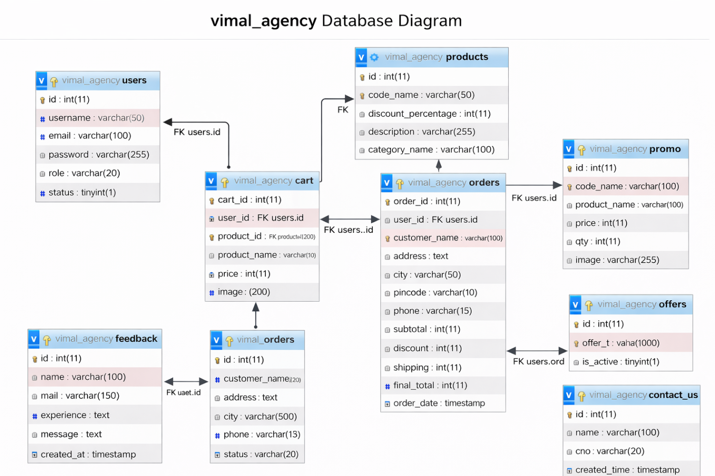

Description

The given class diagram represents the database structure of the “Vimal Agency” system. It illustrates the key entities such as users, products, cart, orders, promo codes, offers, contact messages, and feedback along with their relationships. The system is developed to efficiently handle product management, order processing, customer interaction, and administrative control for an online distribution platform.

1. Users Table (users)
Purpose:
Stores account details of customers and administrators who access the system.

Attributes:
- id – Unique identifier for each user.
- username – User login name.
- email – Registered email address.
- password – Encrypted password for authentication.
- role – Defines whether the account is ‘admin’ or ‘user’.
- status – Indicates whether the account is active or inactive.
- created_at – Date and time of account creation.

2. Products Table (products)
Purpose:
Contains complete information about all available products.

Attributes:
- listing_code – Unique product identifier.
- code – Product code.
- product_name – Name of the product.
- product_price – Price of the product.
- product_category – Category (e.g., Wafers, Namkeen, Snacks).
- product_describe – Description of the product.
- product_image – Image path or URL.

Relationship:
- Products are added and managed by Admin.
- Products are added to Cart.
- Products appear in Order Items after purchase.

3. Cart Table (cart)
Purpose:
Temporarily stores products selected by users before placing an order.

Attributes:
- cart_id – Unique cart record ID.
- user_id – Foreign key linked to users.id.
- product_id – Product reference.
- product_name – Name of product.
- price – Product price.
- qty – Quantity selected.
- image – Product image path.

Relationship:
- Users → Cart (One user can have multiple cart items).
- Products → Cart.

4. Orders Table (orders)
Purpose:
Stores details of orders placed by users.

Attributes:
- order_id – Unique order ID.
- user_id – Foreign key referencing users.id.
- customer_name – Name of the customer.
- address – Shipping address.
- city – Delivery city.
- pincode – Postal code.
- phone – Customer contact number.
- subtotal – Total before discount.
- discount – Discount applied.
- shipping – Shipping charges.
- final_total – Final payable amount.
- status – Order status (Pending, Delivered, Cancelled).
- order_date – Date and time of order placement.

Relationship:
- Users → Orders (One user can place multiple orders).
- Orders → Order Items.

5. Order Items Table (order_items)
Purpose:
Stores individual products within an order.

Attributes:
- item_id – Unique record ID.
- order_id – Foreign key referencing orders.order_id.
- product_name – Purchased product name.
- price – Price at time of purchase.
- qty – Quantity purchased.
- image – Product image reference.

Relationship:
- Orders → Order Items (One order contains multiple items).

6. Promo Table (promo)
Purpose:
Stores promotional codes and discount rules.

Attributes:
- id – Unique promo ID.
- code_name – Promo code name.
- discount_percentage – Discount value.
- description – Promo description.
- category_name – Applicable product category.
- min_order_amount – Minimum order amount to apply promo.

7. Offers Table (offers)
Purpose:
Stores special offers displayed on the website.

Attributes:
- id – Unique offer ID.
- offer_text – Offer description.
- is_active – Indicates if offer is active.

8. Feedback Table (feedback)
Purpose:
Collects feedback and ratings from users.

Attributes:
- id – Unique feedback ID.
- name – Name of the user.
- mail – Email of the user.
- experience – Rating or experience level.
- message – Feedback content.
- created_at – Date of submission.

9. Contact Us Table (contact_us)
Purpose:
Stores customer inquiries and support messages.

Attributes:
- id – Unique message ID.
- name – Sender name.
- email – Sender email.
- cno – Contact number.
- message – Message content.
- created_time – Submission timestamp.

Relationships Overview
- Users → Cart (One-to-Many)
- Users → Orders (One-to-Many)
- Orders → Order Items (One-to-Many)
- Products → Cart (One-to-Many)
- Products → Order Items (Logical Relationship)
- Admin (via role field) → Products & Orders Management
- Feedback & Contact Us are independent support modules

4.4 Use Case Diagram
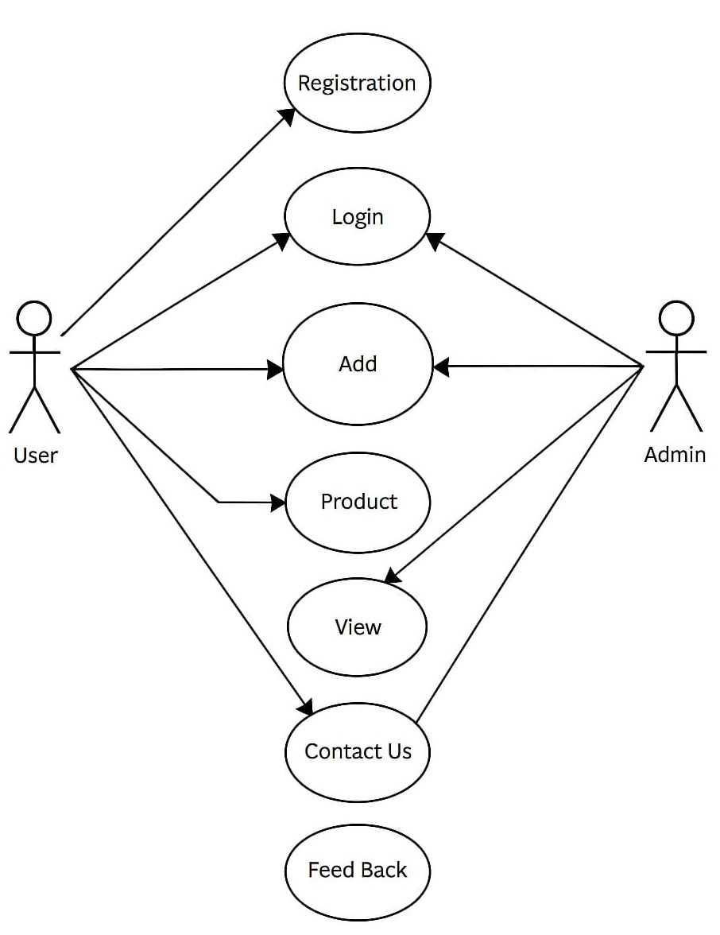

Description

1. User:
Represents the customer who interacts with the Vimal Agency system to register, log in, browse products, add items to cart, place orders, and contact support.

2. Admin:
Represents the system administrator who manages users, products, orders, promo codes, offers, and overall system operations.

Use Cases:

1. Registration:
The User registers by providing required personal details such as username, email, and password to create a new account in the system.

2. Login:
Both User and Admin can log in to access their respective dashboards and functionalities based on their role.

3. Manage Products:
- The Admin can add, update, or delete products in the system.
- The User can browse and view available products.

4. Add to Cart:
- The User can add selected products to the cart.
- The User can update quantity or remove items from the cart.

5. Place Order:
- The User can confirm the cart items and place an order.
- The system calculates subtotal, discount, shipping charges, and final total.

6. Manage Orders:
- The Admin can view all orders.
- The Admin can update order status (Pending, Delivered, Cancelled).
- The User can view their own order history.

7. Apply Promo Code:
- The User can apply valid promo codes during checkout.
- The Admin can create and manage promo codes.

8. Contact Us:
- The User can contact the administrator or support team for assistance or inquiries.
- The Admin can view contact messages submitted by users.

9. Feedback:
- The User can submit feedback or ratings about products and services.
- The Admin can view and manage feedback submissions.

10. View Data:
- Users can view product listings, order details, and account information.
- Admin can view user records, product details, and system reports.

4.5 Sequence Diagram

Product Details
Select Product
Add To Card
Admin
User
Buy Product

Description
• Admin: The administrator who manages product information, updates inventory, and controls order processing in the system.
• User: The customer who browses products, adds items to the cart, and places orders through the Vimal Agency website.

Sequence of Interactions:

1. View Products
o The Admin uploads and maintains product details in the system database.
o The System displays available product details (name, price, image, category) to the User.
o This step represents fetching product data from the database and showing it on the website.

2. Select Product
o The User selects a product from the product list.
o The system processes the request and identifies the selected product.
o This indicates that the user has chosen a product for further action.

3. Add to Cart
o The User sends an Add to Cart request to the system.
o The system verifies product availability.
o The selected product is stored in the Cart table in the database.
o The system confirms that the product has been successfully added to the cart.

4. Apply Promo Code (Optional)
o The User enters a promo code during checkout.
o The system validates the promo code from the Promo table.
o If valid, the system applies the discount to the total amount.

5. Buy Product / Place Order
o The User sends a Place Order request.
o The system calculates subtotal, discount, shipping charges, and final total.
o The system stores order details in the Orders table.
o Individual products are stored in the Order_Items table.
o The system confirms order placement and updates order status.

6. Order Management (Admin Side)
o The Admin views the new order.
o The Admin updates order status (Pending, Delivered, Cancelled).
o The system updates the order record accordingly.

4.6 Activity Diagram
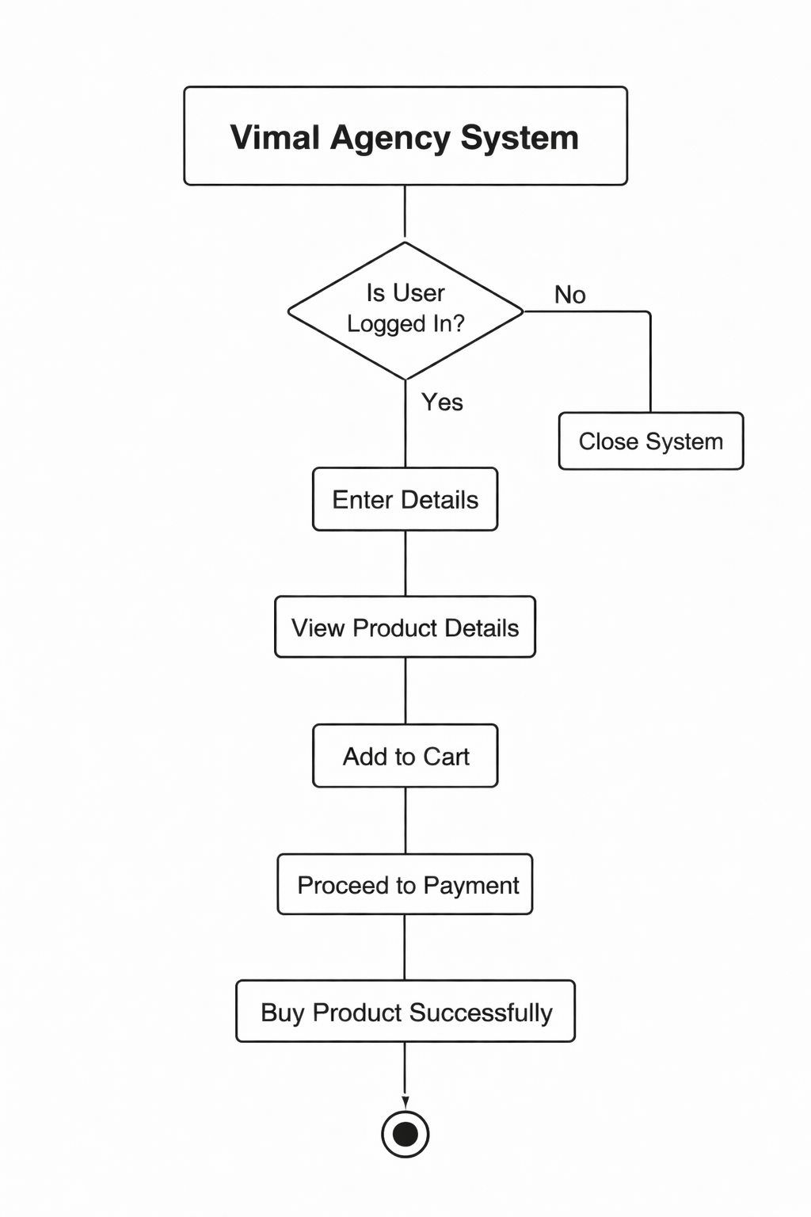

Description
The above activity diagram represents the process flow of the Vimal Agency system, which illustrates how a user interacts with the platform to browse and purchase products efficiently.

1. Vimal Agency
The process begins with the Vimal Agency system, representing the main website or platform for product browsing and purchasing.

2. Login (Decision)
The user is prompted to log in to access the system.
- If the user logs in successfully, they proceed to the next step.
- If not, the user can choose to close the application.

3. Enter Details
Once logged in, the user enters their personal or required details, ensuring the system can identify and authorize access.

4. View Product Details
The user can browse and view the details of available Vimal Agency products, including product name, quantity, price, and stock information.

5. Select Product
The user selects a desired product from the available list.

6. Add to Cart
After selection, the user adds the chosen product to their shopping cart for review before confirming the order.

7. Order Confirmed Successfully
Once the order process is completed, the system confirms that the product has been successfully ordered.

4.7 Database Dictionary

1.User
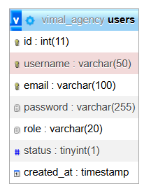

2. Product
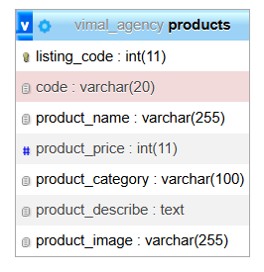

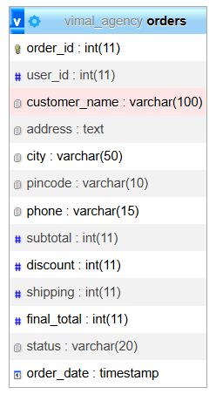
3.Order

4.Order Items
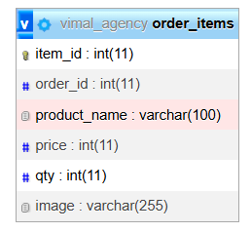

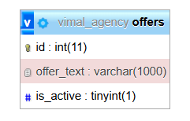
5.Offers

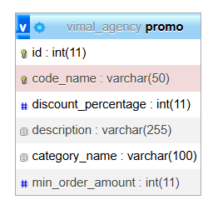
6.Promo

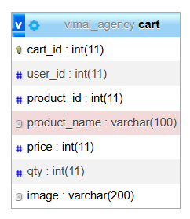
7.Cart

8.Contact_Message
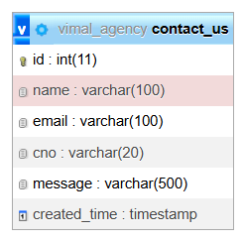

9.Feedback
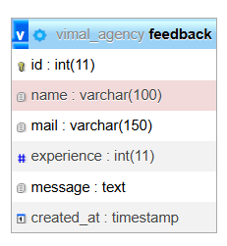

Description

1. User Table (users)
Purpose:
Stores information of all users including admin and customers who access the system.
Attributes:
- id – Unique identifier for each user.
- username – User login name.
- email – User’s email address.
- password – Encrypted password for authentication.
- role – Defines user role (admin / customer).
- status – Account status (active/inactive).
- created_at – Timestamp when the account was created.

2. Products Table (products)
Purpose:
Contains all product details available in Vimal Agency.
Attributes:
- listing_code – Unique listing ID of product.
- code – Product code number.
- product_name – Name of the product.
- product_price – Price of the product.
- product_category – Category of product.
- product_describe – Description of product.
- product_image – Path/filename of product image.

3. Orders Table (orders)
Purpose:
Stores complete order details placed by users.
Attributes:
- order_id – Unique order ID.
- user_id – Foreign key linked to users.id.
- customer_name – Name of customer placing order.
- address – Delivery address.
- city – Customer city.
- pincode – Postal code.
- phone – Contact number.
- subtotal – Total amount before discount/shipping.
- discount – Discount amount applied.
- shipping – Shipping charge.
- final_total – Final payable amount.
- status – Order status (Pending, Confirmed, Delivered, etc.).
- order_date – Date and time of order.

4. Order Items Table (order_items)
Purpose:
Stores individual product items inside each order.
Attributes:
- item_id – Unique ID for each order item.
- order_id – Foreign key referencing orders.order_id.
- product_name – Name of ordered product.
- price – Product price at time of purchase.
- qty – Quantity ordered.
- image – Product image reference.

5. Cart Table (cart)
Purpose:
Temporarily stores products added to cart before order confirmation.
Attributes:
- cart_id – Unique cart ID.
- user_id – Linked to users.id.
- product_id – Linked to products.listing_code.
- product_name – Name of product.
- price – Product price.
- qty – Quantity selected.
- image – Product image reference.

6. Offers Table (offers)
Purpose:
Stores promotional offers displayed in the system.
Attributes:
- id – Unique offer ID.
- offer_text – Description of offer.
- is_active – Status of offer (1 = active, 0 = inactive).

7. Promo Table (promo)
Purpose:
Stores promo codes and discount rules.
Attributes:
- id – Unique promo ID.
- code_name – Promo code name.
- discount_percentage – Discount percentage applied.
- description – Promo description.
- category_name – Applicable category.
- min_order_amount – Minimum order amount required.

8. Feedback Table (feedback)
Purpose:
Stores customer feedback and reviews.
Attributes:
- id – Unique feedback ID.
- name – Customer name.
- mail – Customer email.
- experience – Rating or experience value.
- message – Feedback message.
- created_at – Submission timestamp.

9. Contact Us Table (contact_us)
Purpose:
Stores customer inquiries submitted through contact form.
Attributes:
- id – Unique contact ID.
- name – Sender name.
- email – Sender email.
- cno – Contact number.
- message – Message content.
- created_time – Timestamp of message.

SYSTEM SCREEN DESIGN

5.1 User View Design

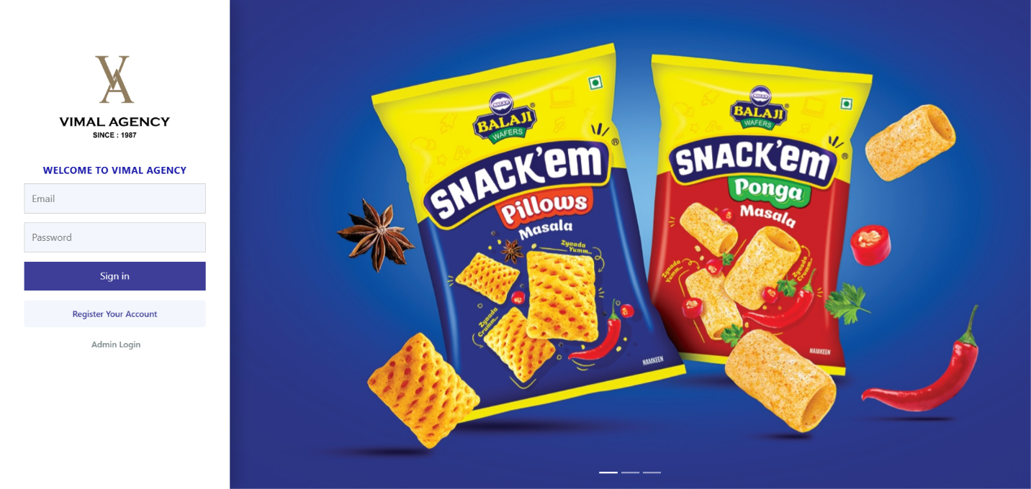
  - Login Page

Description
This image shows the User Login Page for the Vimal Agency Web Application. The design is clean, modern, and aligned with the company’s branding style.
Key Components:
• Left Branding Panel:
The left side features the Vimal Agency logo with “Since 1987” tagline, maintaining a professional corporate identity.
• Login Form Card (Centered Layout):
A neatly aligned login card is placed on the left section for user authentication.
- Email Field:
A standard input field for registered user email.
- Password Field:
A secure password input field with hidden characters.
- Sign In Button:
A bold primary-colored button used for user login.
- Register Account Link:
A link below the login button for new users to create an account.
- Admin Login Link:
A separate link provided for administrators to navigate to the dedicated Admin Login page.
• Right Side Banner Section:
A visually appealing promotional banner displaying product images (e.g., snack packs), enhancing branding and making the login page more attractive.

  - Register Page

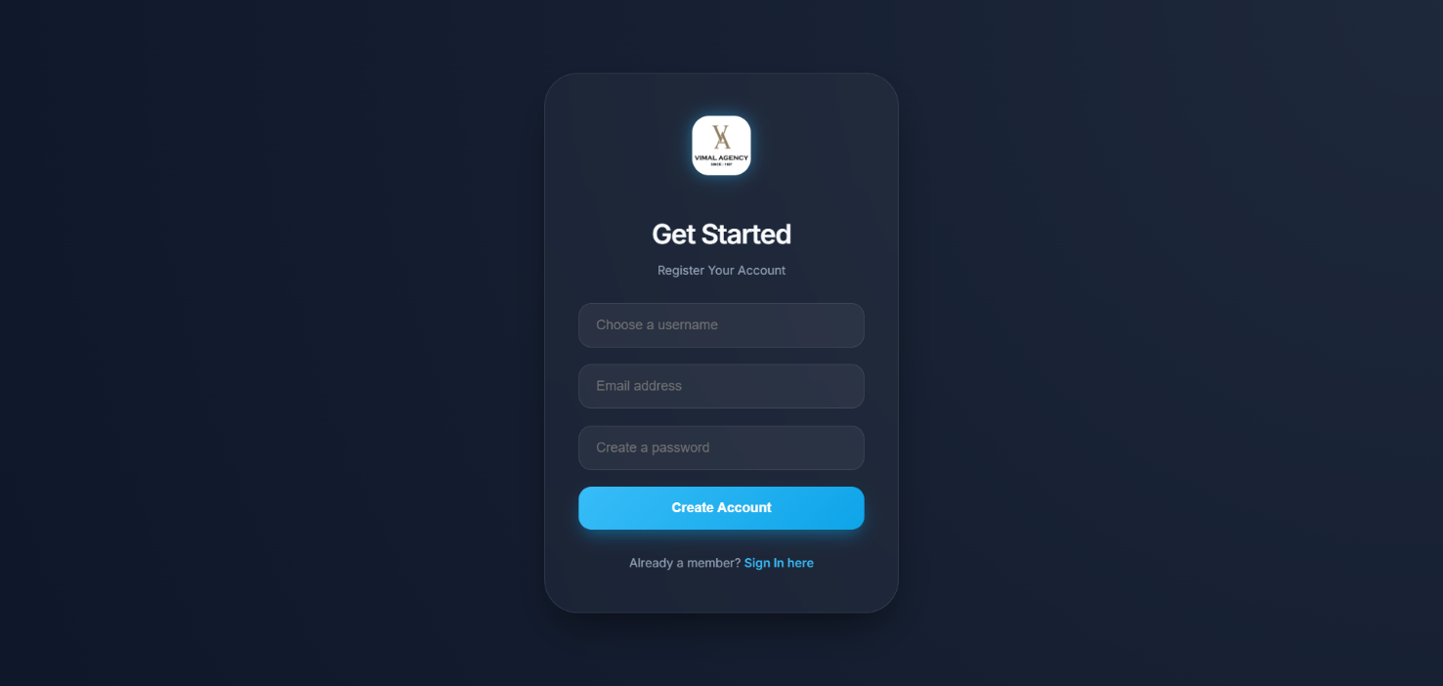

Description

Design Overview:
The page follows a modern dark theme design with a centered glass-style card layout, giving it a professional and premium look.

Key Components:
• Logo Section (Top Center):
The Vimal Agency logo is displayed at the top of the card to maintain brand identity.
• Heading – “Get Started”
A clear and attractive heading encouraging users to register.
• Username Field:
Input field where the user selects a unique username.
• Email Address Field:
Field to enter a valid email address for account registration.
• Create Password Field:
Secure password input field for account protection.
• Create Account Button:
A prominent blue gradient button used to submit the registration form.
• Sign In Link:
Below the button, a navigation link is provided:
“Already a member? Sign In here” — allowing existing users to login.

  - Index Page
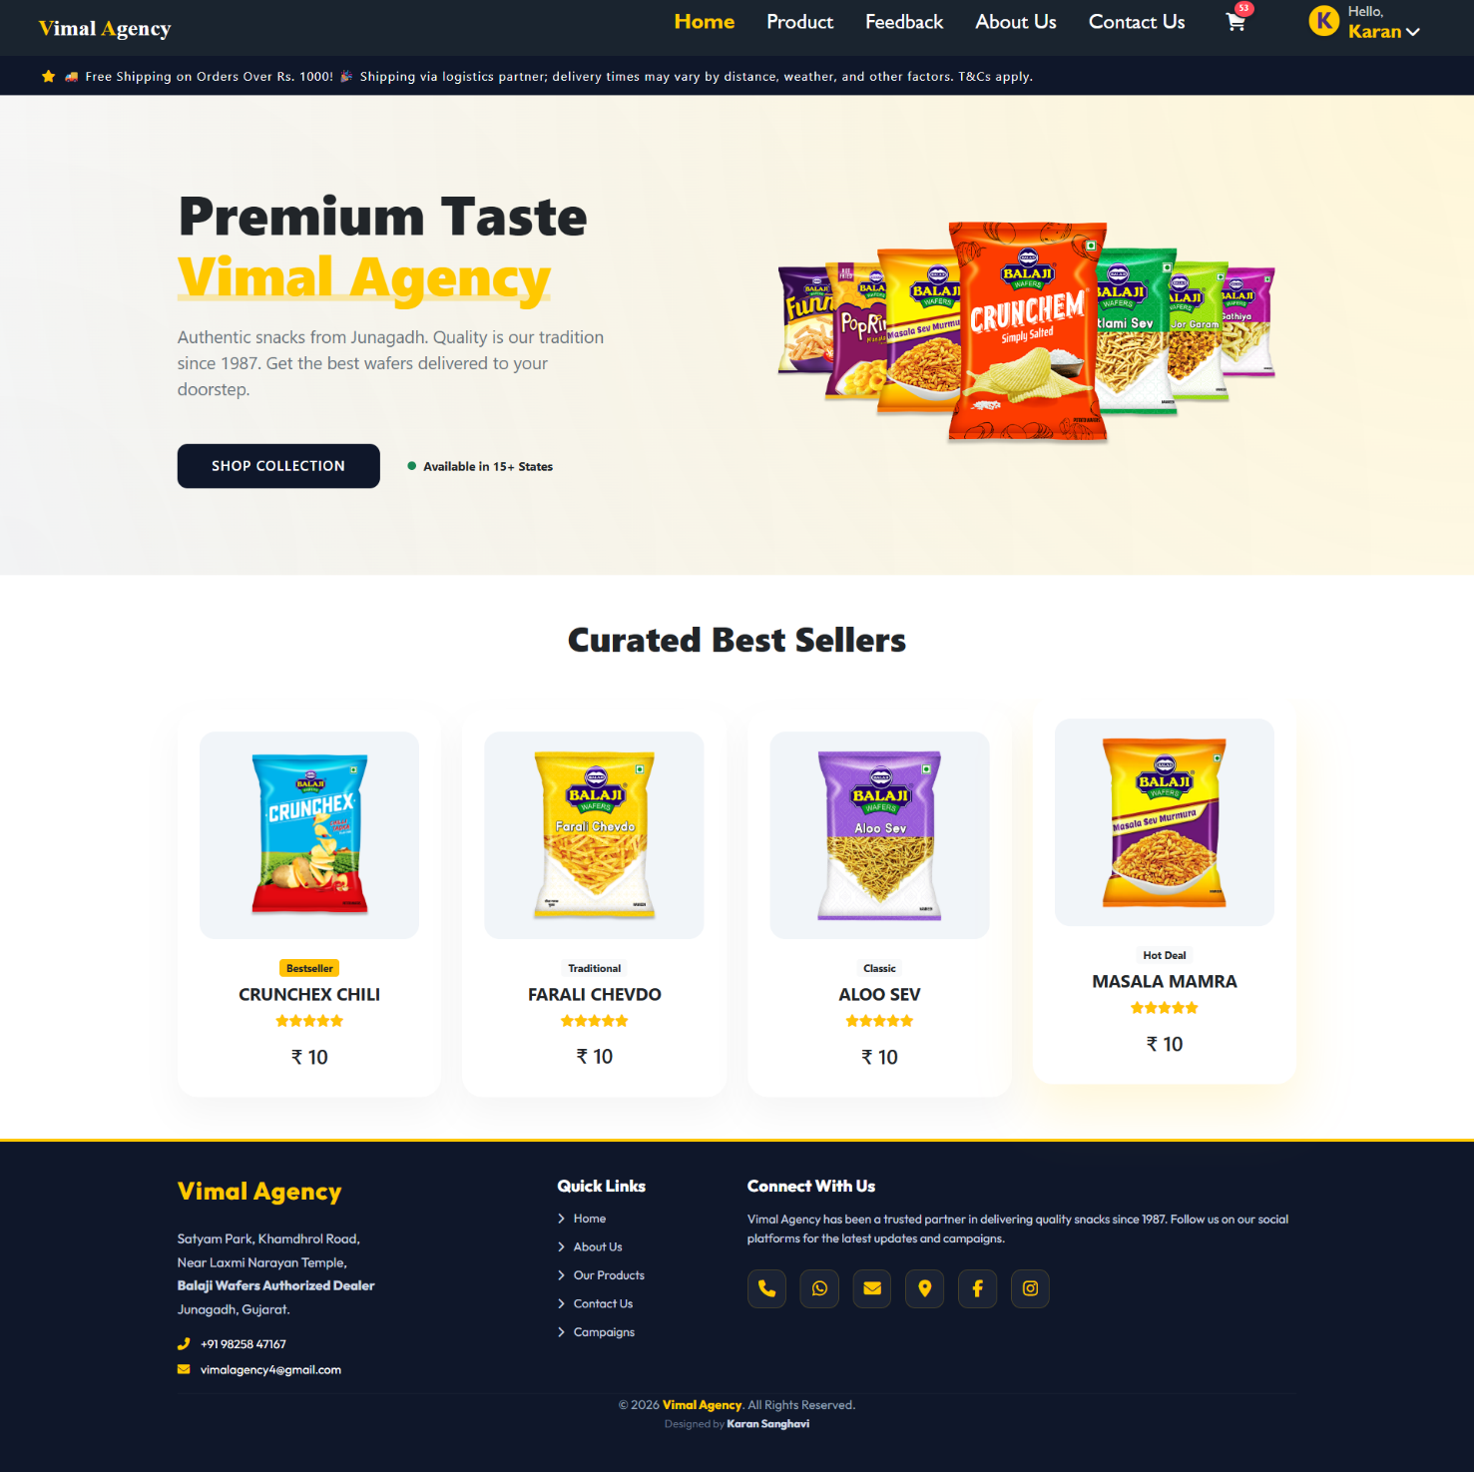

Description
The image shows a full-screen homepage of a snack distribution business called “Vimal Agency.” The website has a modern e-commerce design with a professional dark-blue and cream color theme.

Header and Navigation
The top navigation bar includes:
- The business name “Vimal Agency” displayed on the top-left.
- Main navigation links:
  - Home
  - Product
  - Feedback
  - About Us
  - Contact Us
- A shopping cart icon showing item count.
- A user profile section on the right displaying:
“Hello, Karan”
A promotional strip above the hero section mentions:
- Free shipping on orders above ₹1000
- Delivery via logistics partner
- Terms & Conditions apply

Main Hero Section
The hero section features a light cream background with product images of Balaji snack packets displayed prominently.

Main Heading:
“Premium Taste Vimal Agency”

Subheading:
“Authentic snacks from Junagadh. Quality is our tradition since 1987. Get the best wafers delivered to your doorstep.”

Call-to-Action Button:
“Shop Collection”
A small highlight mentions:
“Available in 15+ States”
This section visually promotes the brand’s premium snack offerings.

Best Seller Section
Below the hero section, there is a heading:

“Curated Best Sellers”
This section displays four product cards:
- CRUNCHEX CHILI – ₹10 (Bestseller)
- FARALI CHEVDO – ₹10 (Traditional)
- ALOO SEV – ₹10 (Classic)
- MASALA MAMRA – ₹10 (Hot Deal)

Each product card includes:
- Product image
- Product name
- Star rating
- Price
- Category label (like Bestseller, Classic, etc.)

Footer Section
The footer has a dark background and includes:

Company Information:
Vimal Agency
Satyam Park, Khamdrol Road,
Near Laxmi Narayan Temple,
Balaji Wafers Authorized Dealer,
Junagadh, Gujarat.
Contact details:
- Phone number
- Email address

Quick Links:
- Home
- About Us
- Our Products
- Contact Us
- Campaigns

Connect With Us:
Social media icons are displayed for communication and engagement.

Copyright:
“© 2026 Vimal Agency. All Rights Reserved.”
Designed by Karan Sanghavi.

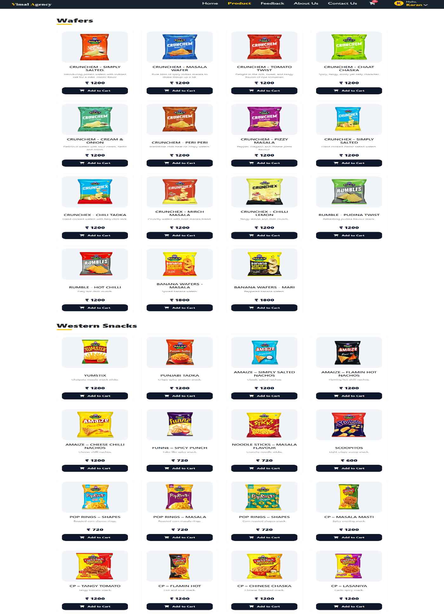
4. Product Page

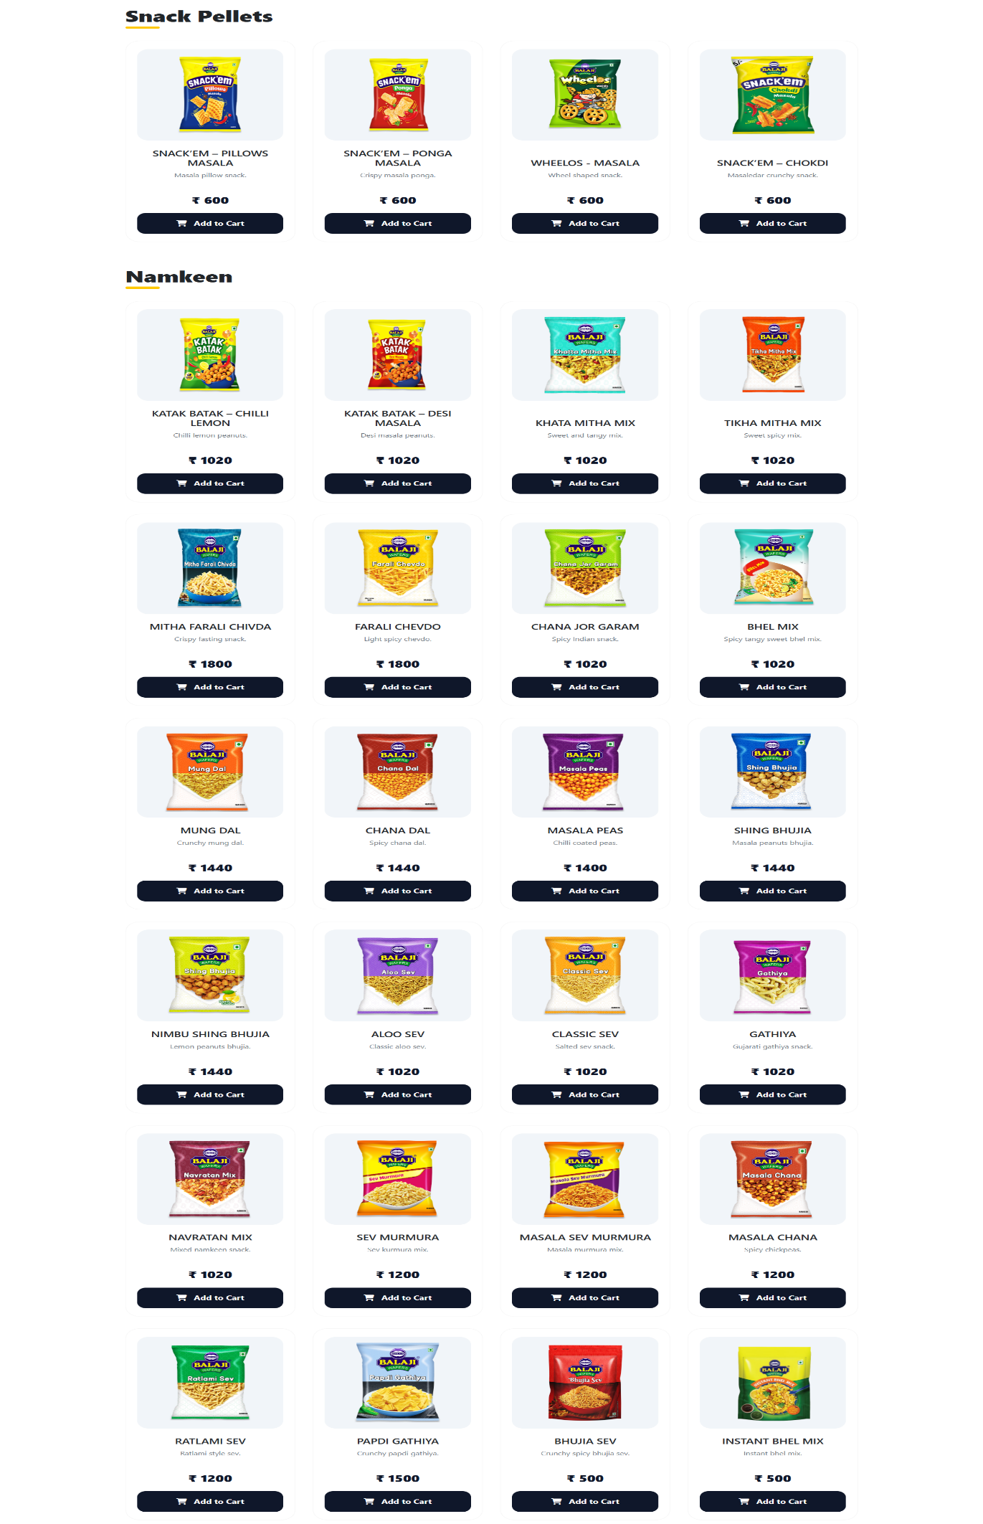
`
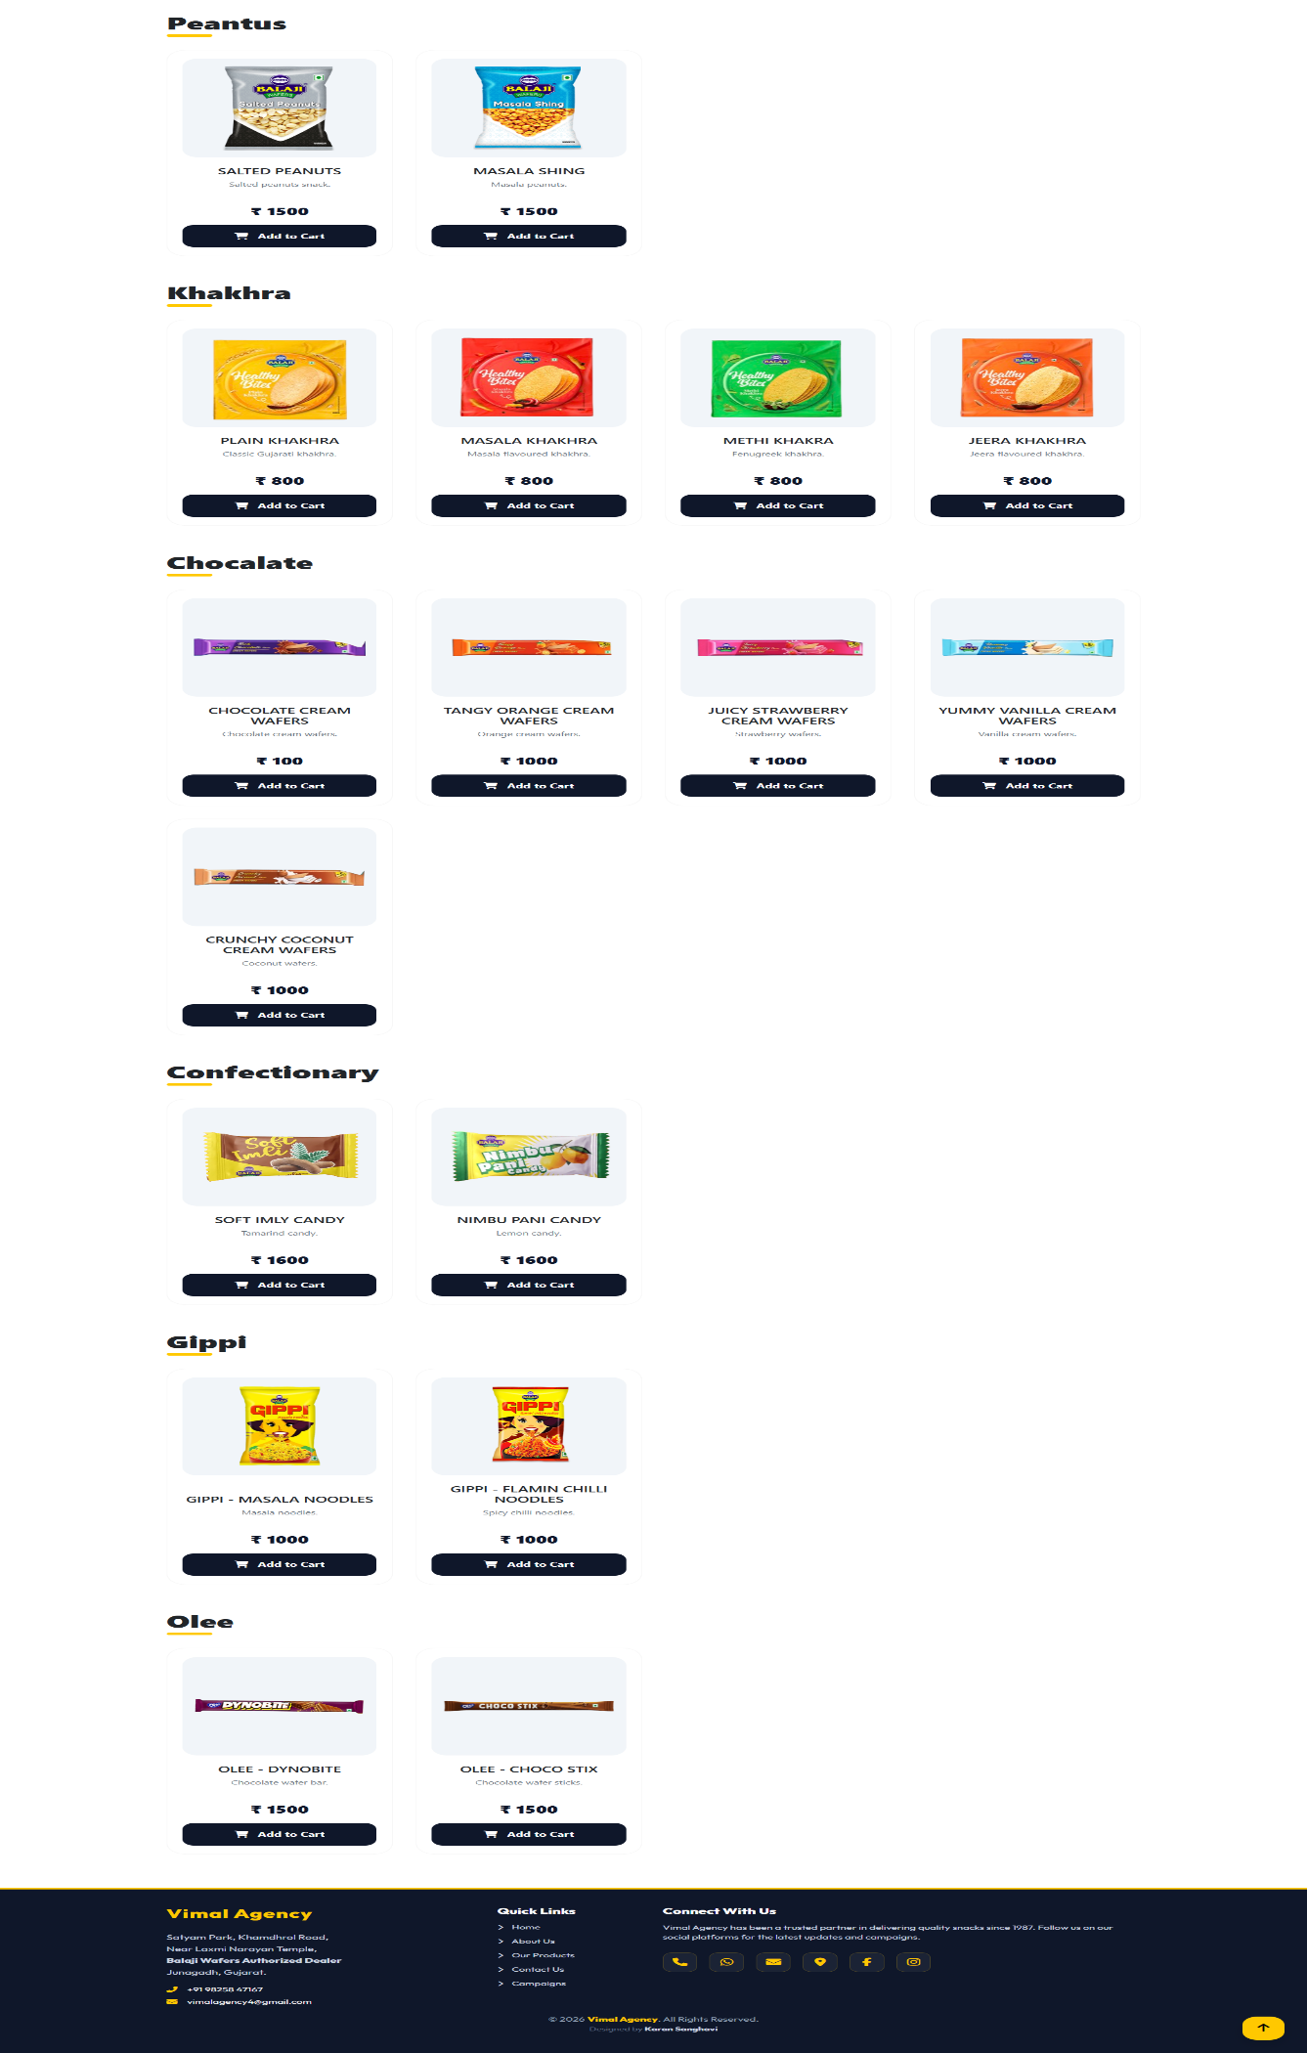

Description
This image shows the Product Page of the Vimal Agency web application, displaying a complete catalog of snack products available for viewing and purchase.

Product Catalog Overview
The page presents a well-structured grid layout of multiple snack categories and products. Each product card includes:
- Product Image
- Product Name
- Price
- “Add to Cart” Button
The clean card-based design makes it easy for users to browse and select products.

Overall Layout
The top section includes a navigation bar with the Vimal Agency logo on the left and menu links such as Home, Products, About Us, Contact Us, and a cart icon on the right.
The products are organized category-wise with clear section headings such as:
- Wafers
- Western Snacks
- Snack Pellets
- Namkeen
- Peanuts
- Khakhra
- Chocolate
- Confectionery
- Gippi
- Olee
Each category displays products in a grid format, typically showing four items per row for better visual alignment.

Product Variety
The catalog features a wide variety of snack items including:
- Different flavors of wafers and chips
- Masala-based namkeen varieties
- Traditional Indian snacks like khakhra
- Sweet items such as chocolates and confectionery
- Branded packaged snacks

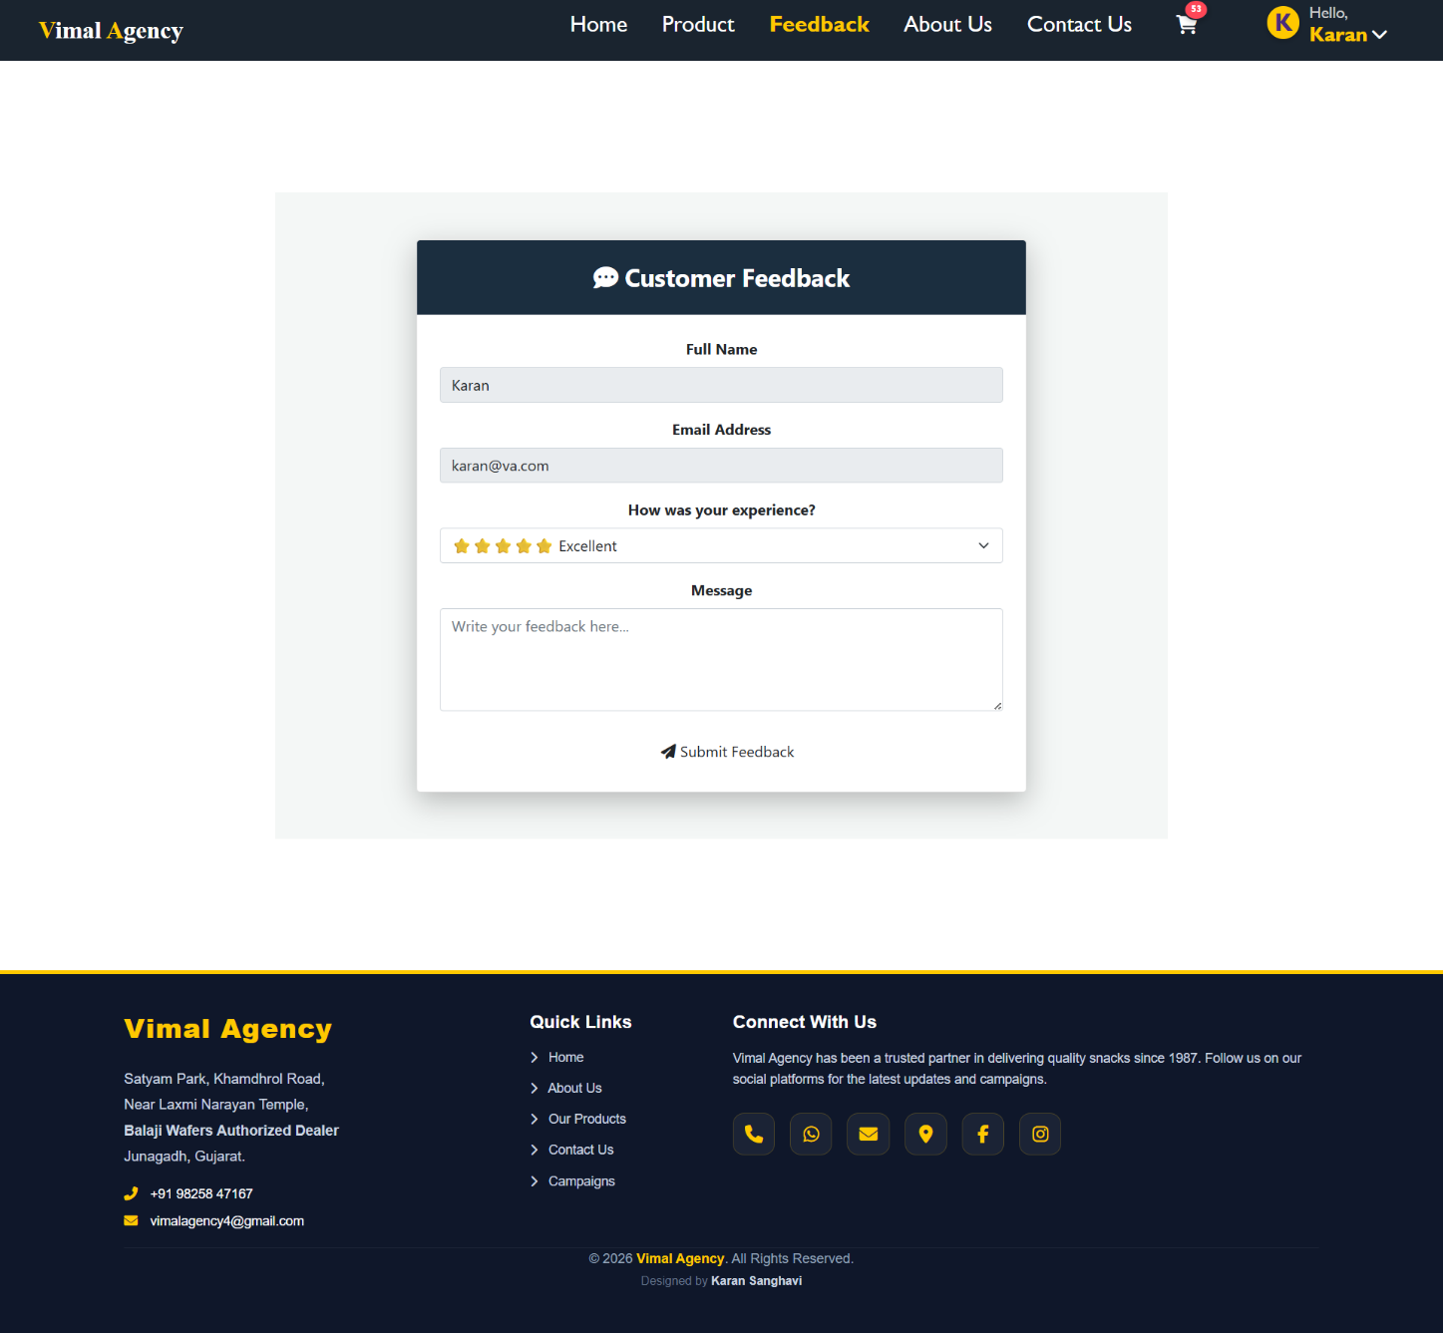
5. Feedback Page

Description
This image displays the Customer Feedback page of the Vimal Agency website, designed to collect customer reviews and improve service quality.

Customer Feedback Form
The page presents a clean, centered feedback card where users can easily share their experience with Vimal Agency.

Feedback Form Content
The form includes the following fields:
- Full Name:
A text field where the customer enters their name.
- Email Address:
An input field for the customer’s email contact.
- Experience Rating:
A dropdown rating system with star indicators (e.g., ★★★★★ Excellent), allowing users to rate their overall experience.
- Message Box:
A larger text area where customers can write detailed feedback, suggestions, or comments.
- Submit Feedback Button:
A clearly visible button with an icon, used to submit the feedback form.

Page Layout & Design
- The page header includes the Vimal Agency logo on the left and navigation links such as Home, Product, Feedback, About Us, and Contact Us.
- A cart icon and user profile greeting (Hello, Karan) are visible on the top-right, indicating that the user is logged in.
- The feedback card is placed centrally with a subtle shadow effect, creating a professional and modern appearance.
- The footer section includes company address, contact number, email, quick links, and social media icons, maintaining branding consistency.

6. Contact us Page
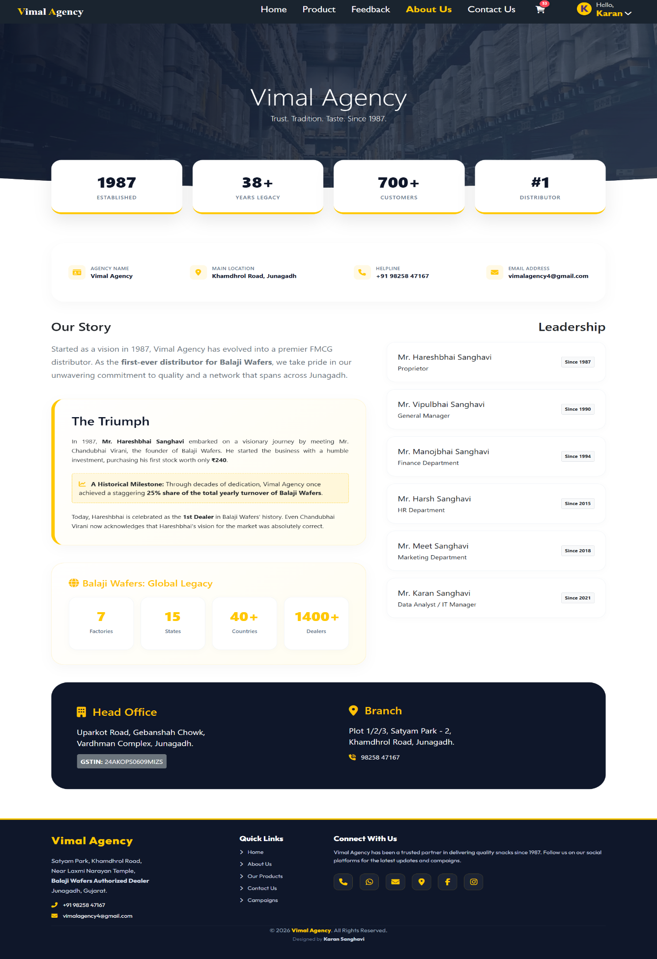

Description
This image displays the About Us page of the Vimal Agency website, highlighting the company’s history, achievements, leadership team, and business presence.

Company Overview Section
At the top, a large banner displays the title “Vimal Agency” with the tagline:
“Trust. Tradition. Taste. Since 1987.”
Below the banner, key business statistics are presented in a visually appealing card format:
- 1987 – Established
- 38+ Years Legacy
- 700+ Customers
- #1 Distributor
This section builds credibility and emphasizes the agency’s strong market presence.

Company Information
A brief information strip provides essential details:
- Agency Name: Vimal Agency
- Main Location: Khamdhrol Road, Junagadh
- Helpline: +91 98258 47167
- Email Address: vimalagency4@gmail.com

Our Story
The “Our Story” section explains the journey of Vimal Agency since 1987.
It highlights:
- Becoming the first-ever distributor for Balaji Wafers
- Strong commitment to quality
- Continuous growth in the FMCG distribution sector

The Triumph (Milestone Section)
This section describes the early journey of Mr. Hareshbhai Sanghavi and the humble investment that started the business.
It also highlights a major milestone:
- Achieving 25% share of total yearly turnover of Balaji Wafers
This reinforces the company’s strong relationship and growth with the brand.

Balaji Wafers: Global Legacy
A highlighted section presents Balaji Wafers’ global impact:
- 7 Factories
- 15 States
- 40+ Countries
- 1400+ Dealers

Leadership Section
On the right side, the page lists the leadership team with designation and service years:
- Mr. Hareshbhai Sanghavi – Proprietor
- Mr. Vipulbhai Sanghavi – General Manager
- Mr. Manojbhai Sanghavi – Finance Department
- Mr. Harsh Sanghavi – HR Department
- Mr. Meet Sanghavi – Marketing Department
- Mr. Karan Sanghavi – Data Analyst / IT Manager

Office Information
At the bottom, the page provides:

Head Office
Uparkot Road, Junagadh
Branch
Plot 1/2/3, Satyam Park-2, Khamdhrol Road, Junagadh

7. Contact us Page
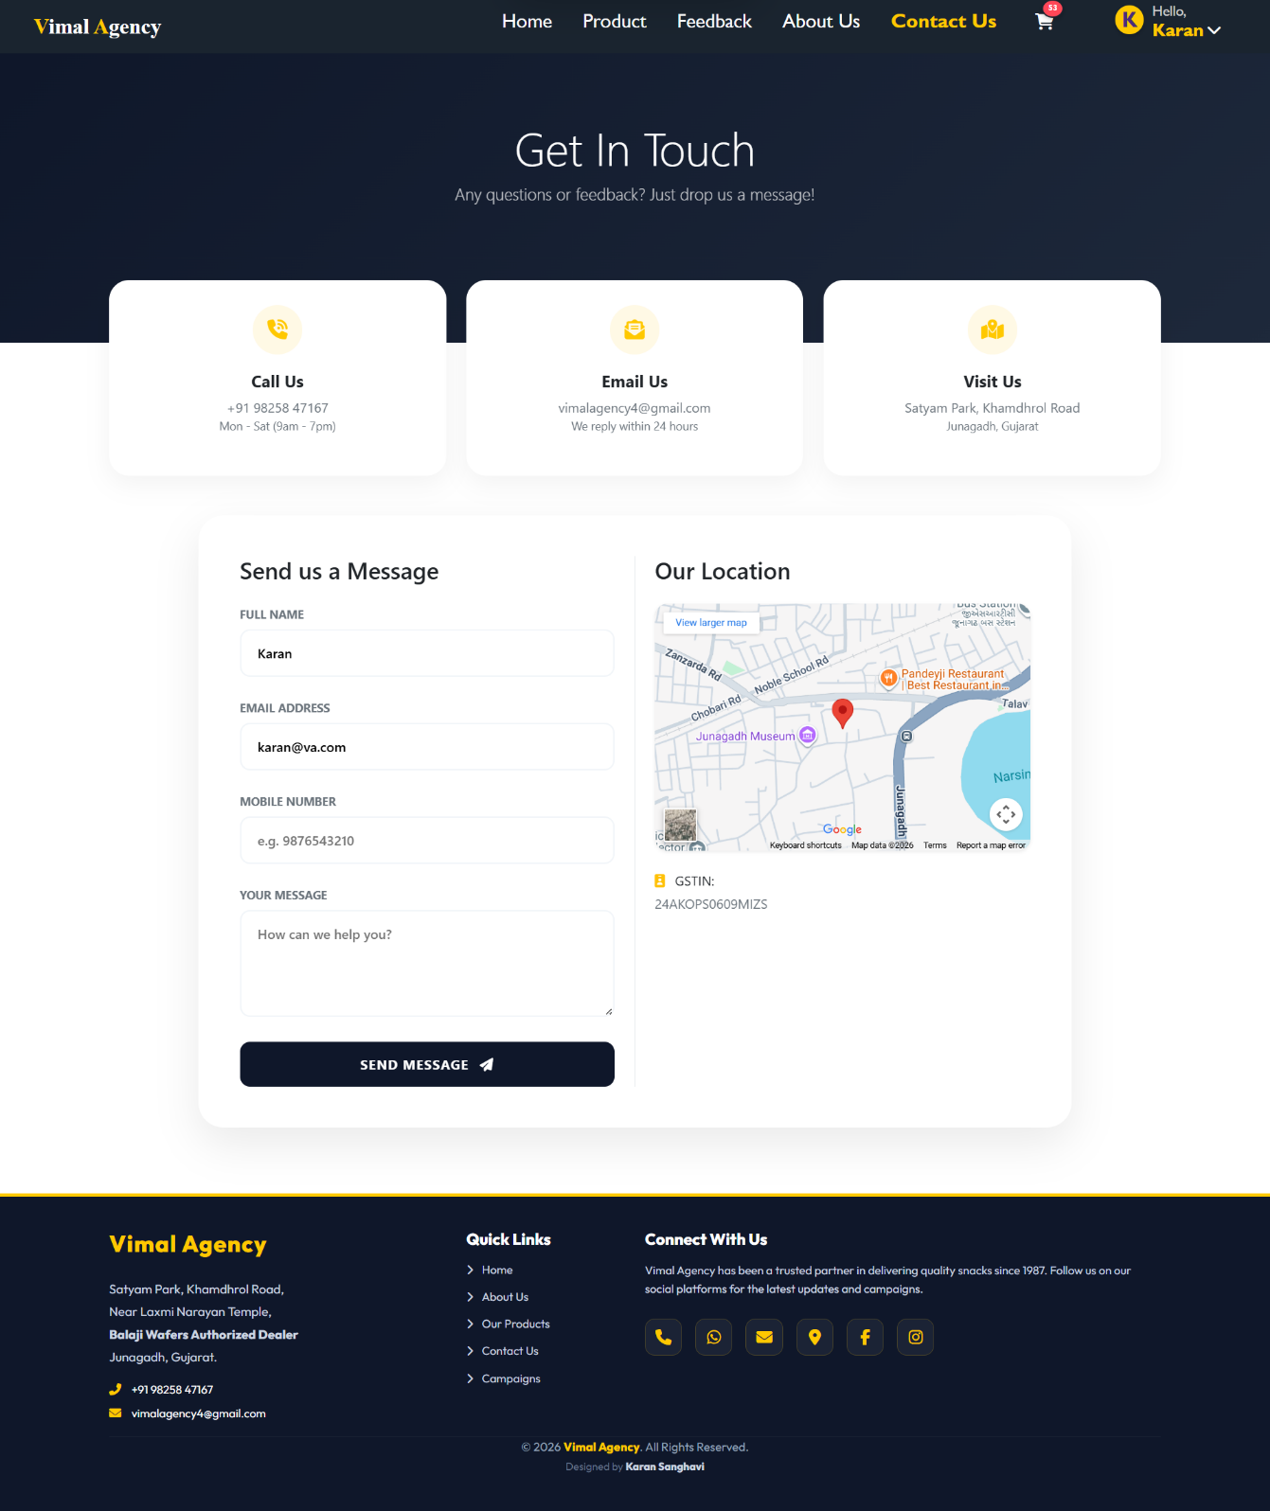

Description
This image displays the Contact Us page of the Vimal Agency website, designed to help customers easily connect with the agency for inquiries, support, or business communication.

Get In Touch Section
At the top of the page, a bold heading reads:
“Get In Touch”
with a subheading:
“Any questions or feedback? Just drop us a message!”
Below this, three contact information cards are displayed:
- Call Us
+91 98258 47167
(Mon – Sat, 9am – 7pm)
- Email Us
vimalagency4@gmail.com
(Response within 24 hours)
- Visit Us
Satyam Park, Khamdhrol Road, Junagadh, Gujarat
This section provides quick access to essential contact details.

Send Us a Message
On the left side, a structured contact form is available where users can submit their queries.

Form Fields:
- Full Name
- Email Address
- Mobile Number
- Your Message (text area)
At the bottom, a bold “Send Message” button allows users to submit their inquiry.

Our Location
On the right side, a Google Map is embedded showing the exact business location in Junagadh.
Below the map, the company’s GSTIN number is also displayed for official reference.

Page Layout & Elements
- Navigation bar at the top with links: Home, Product, Feedback, About Us, Contact Us
- Cart icon and logged-in user greeting (Hello, Karan) visible in the header
- Clean two-column layout (Form + Map) for better usability
- Professional dark-themed footer with address, contact details, quick links, and social media icons

8. Cart
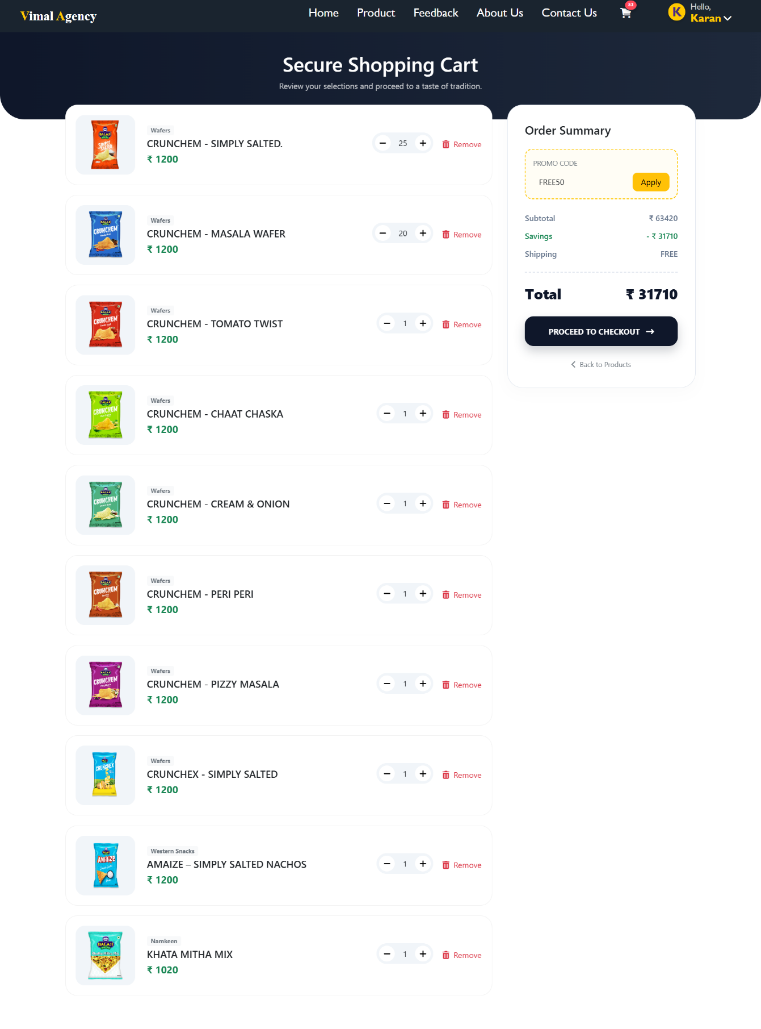

Description
This image displays the Secure Shopping Cart page of the Vimal Agency website, where customers can review selected products before proceeding to checkout.

Secure Shopping Cart Section
At the top, a bold heading reads:
“Secure Shopping Cart”
with a subtitle:
“Review your selections and proceed to a taste of tradition.”
This creates a professional and secure shopping experience.

Cart Items List
The left side of the page shows a detailed list of selected products in card format.
Each product entry includes:
- Product Image
- Category Name (e.g., Wafers, Western Snacks, Namkeen)
- Product Name (e.g., Crunch’em flavors, Amaize Nachos, Khata Mitha Mix)
- Price (₹)
- Quantity Controls ( + / – buttons )
- Remove Option
This allows users to easily increase, decrease, or remove items from the cart.

Order Summary Section
On the right side, a structured Order Summary panel is displayed.

It includes:
- Promo Code Field (Example: FREE50 with Apply button)
- Subtotal Amount
- Savings
- Shipping Charges (FREE)
- Final Total Amount
A prominent “Proceed to Checkout” button is provided to complete the purchase.
There is also a “Back to Products” link for continued shopping.

Page Layout & Elements
- Top navigation bar with links: Home, Product, Feedback, About Us, Contact Us
- Cart icon with item count visible
- Logged-in user greeting: “Hello, Karan”
- Two-column layout (Cart Items + Order Summary)
- Clean card design with rounded corners and subtle shadows
- Dark-themed professional footer with company details

9. Checkout
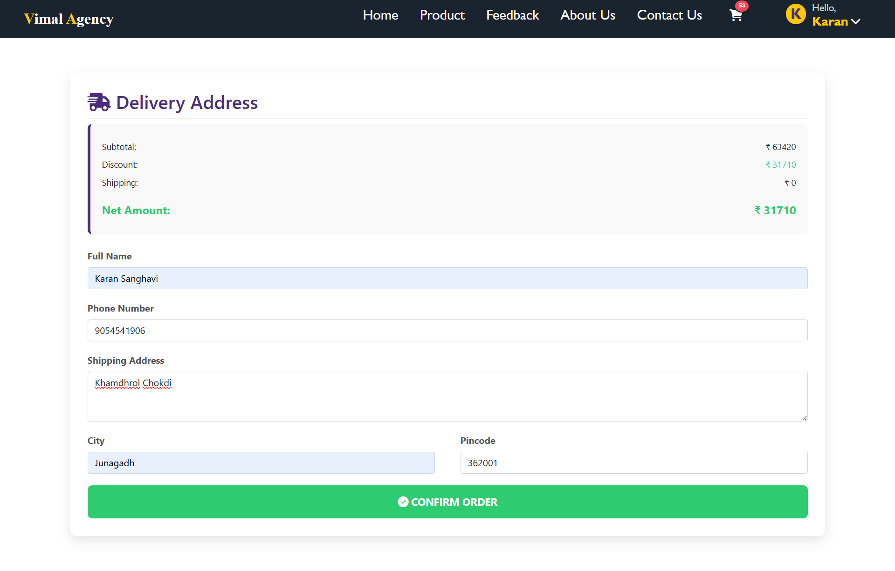

Description
This image displays the Delivery Address (Checkout) page of the Vimal Agency website, where customers enter their shipping details before confirming the order.

Delivery Address Section
At the top, a heading titled “Delivery Address” is displayed along with a delivery icon, indicating the final step before order confirmation.
Below the heading, a billing summary panel is shown containing:
- Subtotal: ₹ 63,420
- Discount: – ₹ 31,710
- Shipping: ₹ 0
- Net Amount: ₹ 31,710 (highlighted in green)
This section provides a clear financial summary of the order before confirmation.

Customer Details Form
The page includes a structured form where users must enter their delivery information.

Form Fields:
- Full Name (e.g., Karan Sanghavi)
- Phone Number
- Shipping Address (detailed address field)
- City (e.g., Junagadh)
- Pincode (e.g., 362001)
The layout is clean and user-friendly, ensuring easy data entry.

Confirm Order Button
At the bottom, a large green “Confirm Order” button is provided.
This button finalizes the order and proceeds with the purchase process.

Page Layout & Elements
- Top navigation bar with menu links (Home, Product, Feedback, About Us, Contact Us)
- Cart icon with item count
- Logged-in user greeting: “Hello, Karan”
- Clear card-style layout with rounded corners
- Professional and minimal design for better user experience

10. Order History
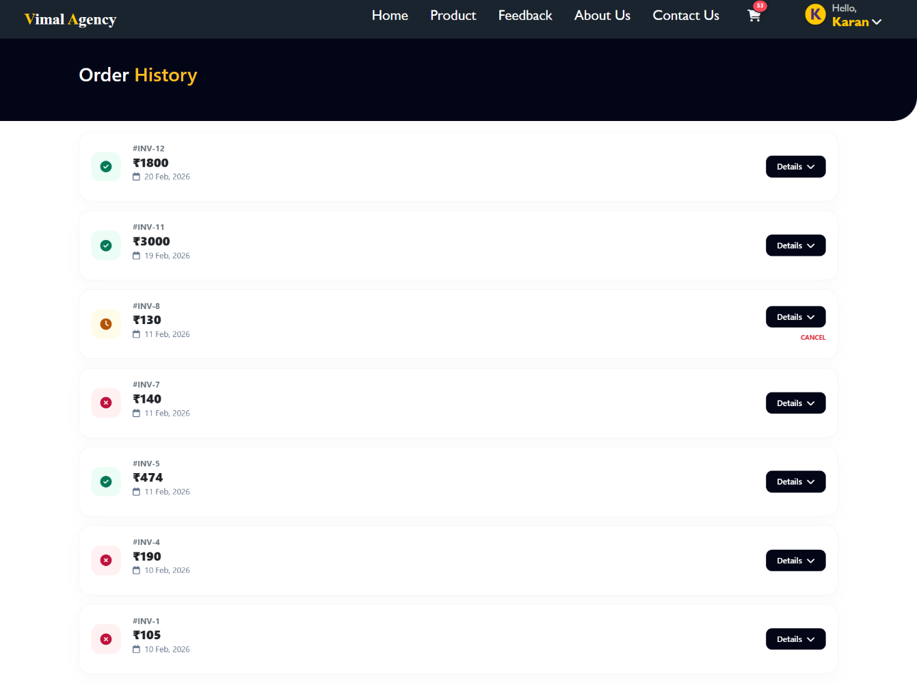

Description
This image displays the Order History page of the Vimal Agency website, where customers can view their previous orders along with status and invoice details.

Order History Section
At the top, a bold heading reads:
“Order History”
This section provides a structured overview of all past purchases made by the logged-in user.

Order List Layout
Each order is displayed in a separate card format containing:
- Invoice Number (e.g., #INV-12, #INV-11)
- Order Amount (₹ value clearly displayed)
- Order Date (e.g., 20 Feb, 2026)
- Status Indicator Icon
- Details Button
The clean card-based layout ensures easy readability and organization.

Order Status Indicators
Different icons visually represent the order status:
- ✅ Green Check Icon – Successfully completed orders
- 🕒 Clock Icon – Pending or processing orders
- ❌ Red Cross Icon – Cancelled orders
Some orders also include a “Cancel” option (if applicable).

Details Option
Each order has a “Details” button, allowing users to:
- View ordered products
- Check billing summary
- Review delivery information
- Track order status

Page Layout & Elements
- Top navigation bar with menu links
- Cart icon with item count
- Logged-in user greeting: “Hello, Karan”
- Minimal and professional UI design
- Consistent dark header theme

5.2 Admin View Design

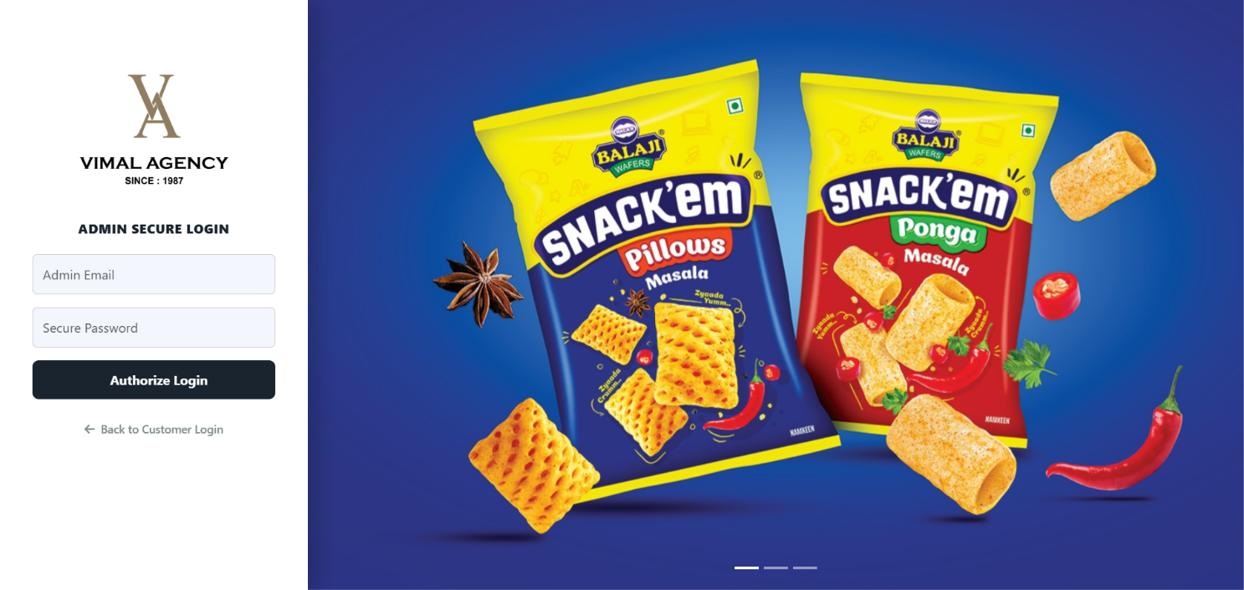
1. Admin Login Page

Description
This image displays the Admin Secure Login page of the Vimal Agency web application, designed specifically for administrative access to the system.

Admin Secure Login Section
On the left side of the page, a dedicated login panel is displayed for administrators.

Branding Area:
- Vimal Agency Logo
- Tagline: “Since 1987”
- Title: “Admin Secure Login”
This clearly distinguishes it from the customer login interface.

Login Form Fields
The admin login form includes:
- Admin Email Field – For entering the authorized administrator email address
- Secure Password Field – A protected password input for authentication
- Authorize Login Button – A bold and prominent button to access the admin dashboard
Below the button, a navigation link is provided:
- “Back to Customer Login” – Allows switching back to the user login page

Right Side Promotional Banner
The right side features a large promotional image showcasing snack products (Balaji Snack’em variants).
The vibrant blue background and floating snack visuals enhance the professional and branded appearance of the page.

Page Layout & Design
- Split-screen layout (Admin Form + Promotional Banner)
- Clean and minimal authentication interface
- Strong branding consistency with the rest of the website
- Secure and professional appearance suitable for administrative access

2. Admin Dashboard Page
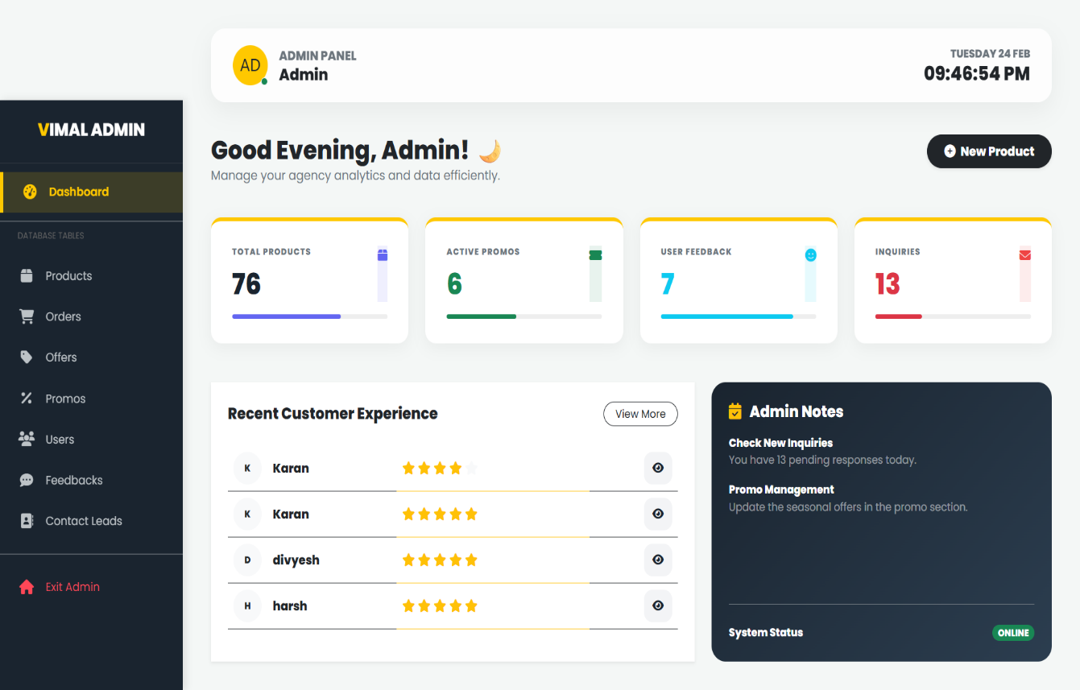

Description
This image displays the Admin Dashboard of the Vimal Agency web application, designed to help administrators manage products, orders, users, and overall system analytics efficiently.

Admin Panel Overview
At the top, the header shows:
- Admin Panel – Admin
- Current Date & Time (e.g., Tuesday 24 Feb, 09:46:54 PM)
- Greeting Message: “Good Evening, Admin!”
- A “New Product” button for quickly adding products
This section provides quick administrative access and system awareness.

Sidebar Navigation Menu
On the left side, a vertical navigation panel titled “Vimal Admin” includes:

Dashboard Section
- Dashboard (active)

Database Tables
- Products
- Orders
- Offers
- Promos
- Users
- Feedbacks
- Contact Leads

At the bottom:
- Exit Admin option
This structured menu allows easy access to all management modules.

Analytics Cards
Below the greeting section, four summary cards display key metrics:
- Total Products: 76
- Active Promos: 6
- User Feedback: 7
- Inquiries: 13
Each card includes a visual progress indicator for better data representation.

Recent Customer Experience
This section lists recent customer feedback entries with:
- Customer Name (e.g., Karan, divyesh, harsh)
- Star Ratings (★★★★★)
- View Icon to check detailed feedback
This helps the admin monitor customer satisfaction levels.

Admin Notes Section
On the right side, an information panel titled “Admin Notes” includes:
- Reminder to check new inquiries
- Promo management update notification

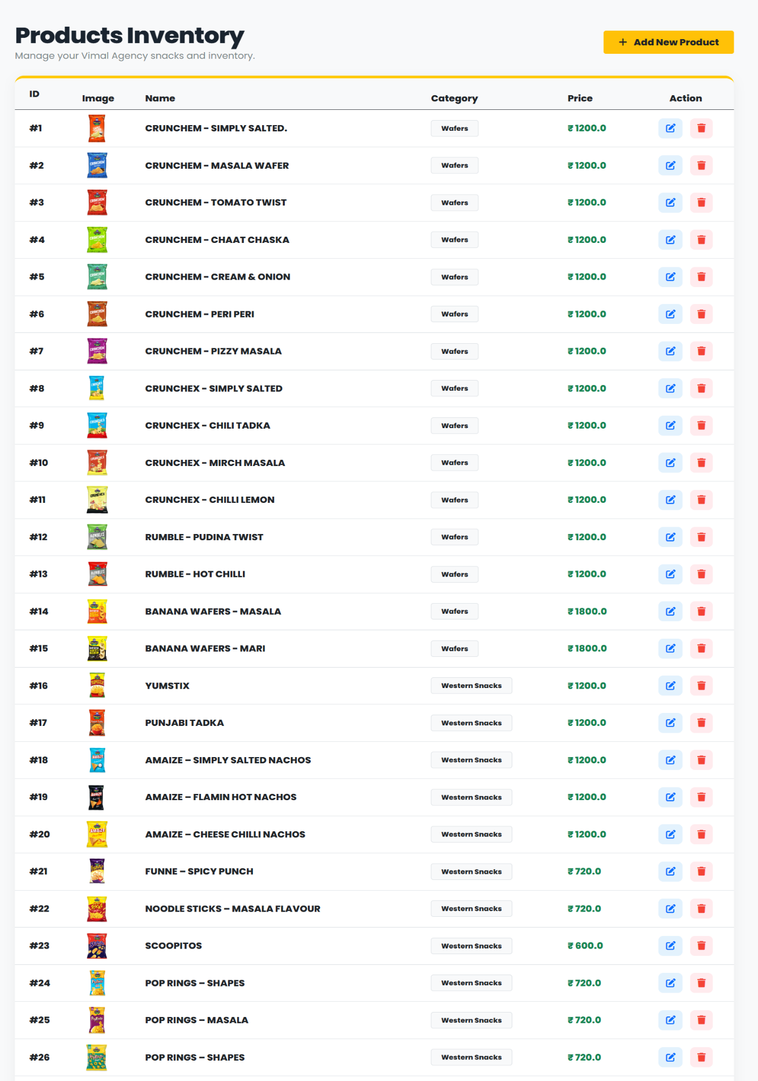
3. Manage Products Page

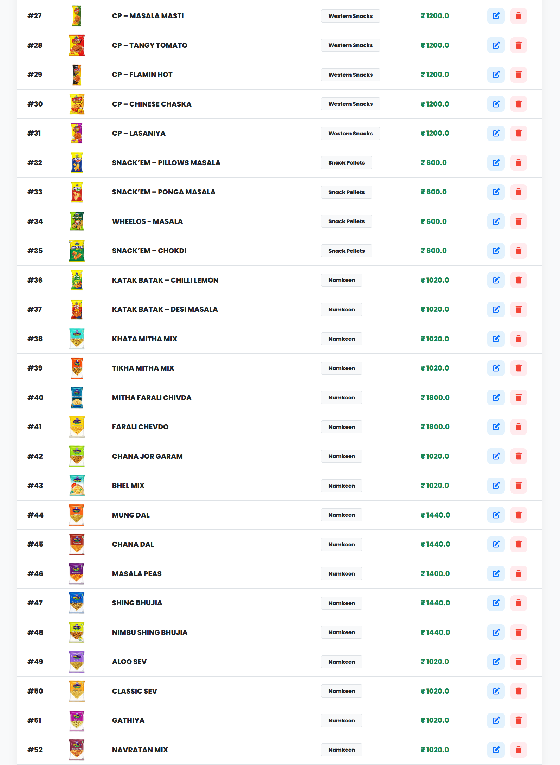
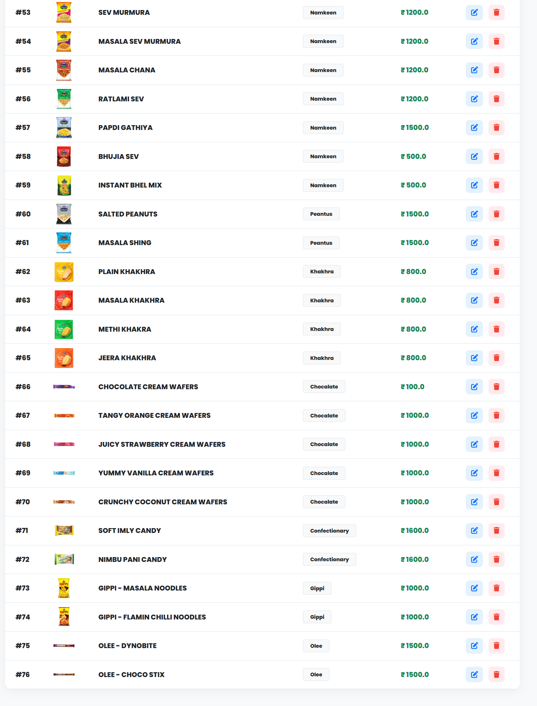

Description
This image displays the Products Inventory page of the Vimal Agency Admin Panel, where the administrator can manage all available products in the system.

Products Inventory Overview
At the top, the page title reads:
“Products Inventory”
with a short description:
“Manage your Vimal Agency snacks and inventory.”
On the right side, a prominent “+ Add New Product” button is provided to allow the admin to add new items to the system.

Inventory Table Structure
The page contains a large structured table with the following columns:
- ID – Unique product identification number
- Image – Small thumbnail preview of the product
- Name – Product name (e.g., Crunch’em, Amaize, Khakhra, Sev, etc.)
- Category – Product category (Wafers, Western Snacks, Namkeen, Peanuts, Khakhra, Chocolate, Confectionery, Gippi, Olee, etc.)
- Price – Product price displayed in ₹
- Action – Edit and Delete buttons

Product Categories Included
The inventory covers a wide variety of snack categories such as:
- Wafers
- Western Snacks
- Snack Pellets
- Namkeen
- Peanuts
- Khakhra
- Chocolate
- Confectionery
- Gippi
- Olee
This demonstrates a complete FMCG product management system.

Action Controls
Each product row includes:
- ✏ Edit Button – To update product details
- 🗑 Delete Button – To remove the product from inventory
This enables full CRUD (Create, Read, Update, Delete) functionality.

4. Manage User Order Page
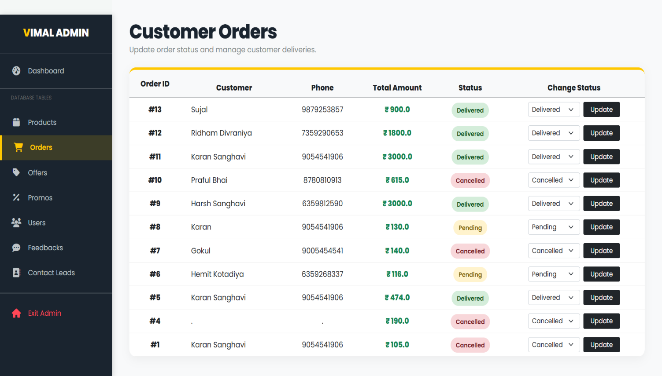

Description
This image displays the Customer Orders page of the Vimal Agency Admin Panel, where the administrator can manage and update customer order statuses.

Customer Orders Overview
At the top, the page title reads:
“Customer Orders”
Below it, a subtitle states:
“Update order status and manage customer deliveries.”
This indicates that the page is focused on order tracking and delivery management.

Orders Table Structure
The page contains a structured table with the following columns:
- Order ID – Unique order number (e.g., #13, #12, #11)
- Customer Name – Name of the customer
- Phone Number – Customer contact number
- Total Amount – Total order value in ₹
- Status – Current order status
- Change Status – Dropdown + Update button

Order Status Types
Different colored status labels are displayed:
- 🟢 Delivered – Order successfully completed
- 🟡 Pending – Order yet to be delivered
- 🔴 Cancelled – Order cancelled
These visual indicators make status identification quick and clear.

Change Status Functionality
Each order row includes:
- A dropdown menu to select new status (Delivered / Pending / Cancelled)
- An Update button to apply the selected change
This allows real-time order management by the administrator.

5. Manage Offer Page
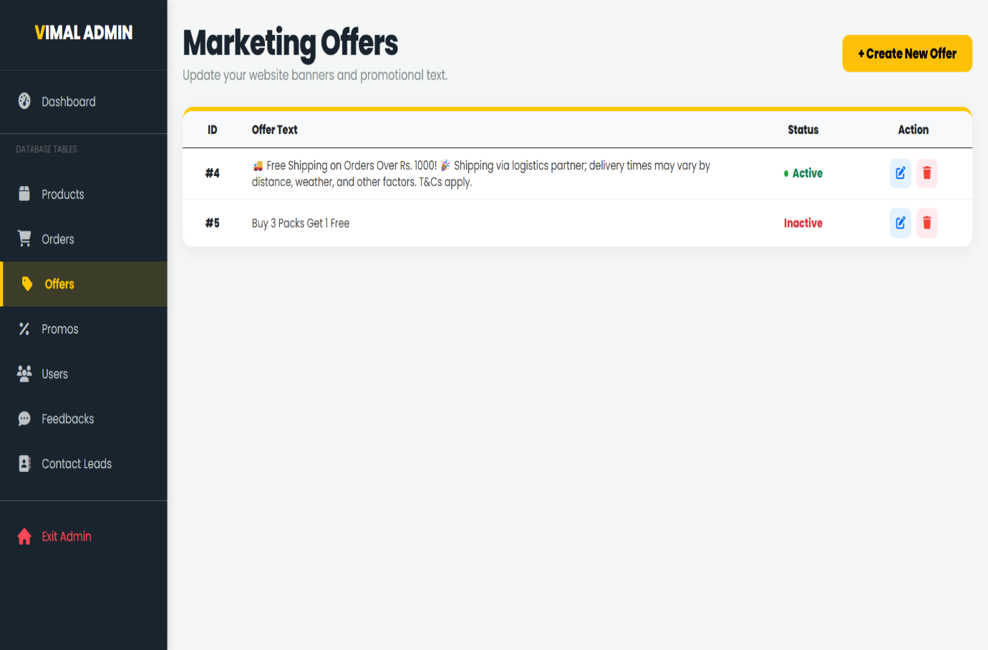

Description
This image displays the Marketing Offers page of the Vimal Agency Admin Panel, where the administrator can manage promotional offers and website banner text.

Marketing Offers Overview
At the top, the page title reads:
“Marketing Offers”
Below it, a subtitle states:
“Update your website banners and promotional text.”
On the right side, a prominent yellow button labeled “+ Create New Offer” is provided for adding new promotional offers.

Offers Table Structure
The page contains a structured table with the following columns:
- ID – Unique offer identification number (e.g., #4, #5)
- Offer Text – Description of the promotional offer
- Status – Current state of the offer
- Action – Edit and Delete buttons

Offer Details
Two example offers are displayed:
- Free Shipping on Orders Over Rs. 1000
Includes additional shipping conditions and terms.
Status: 🟢 Active
- Buy 3 Packs Get 1 Free
Status: 🔴 Inactive
The status indicator clearly shows whether the offer is currently visible on the website.

Action Controls
Each offer row includes:
- ✏ Edit Button – To modify the offer text or status
- 🗑 Delete Button – To remove the promotional offer
This enables full offer management functionality.

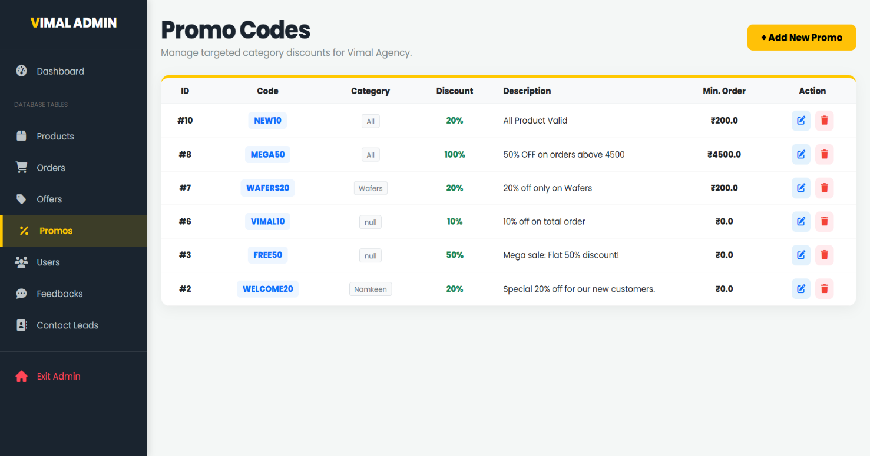
6. Manage Promo Page

Description
This image displays the Promo Codes page of the Vimal Agency Admin Panel, where the administrator can manage discount coupons and category-based promotional codes.

Promo Codes Overview
At the top, the page title reads:
“Promo Codes”
Below it, a subtitle states:
“Manage targeted category discounts for Vimal Agency.”
On the right side, a prominent yellow button labeled “+ Add New Promo” is available to create new discount codes.

Promo Codes Table Structure
The page contains a structured table with the following columns:
- ID – Unique promo identification number (e.g., #10, #8, #7)
- Code – Promo code name (e.g., NEW10, MEGA50, WAFERS20)
- Category – Applicable product category (All, Wafers, Namkeen, etc.)
- Discount – Discount percentage (%)
- Description – Details about the promo offer
- Min. Order – Minimum order amount required to apply the promo
- Action – Edit and Delete buttons

Example Promo Codes
Some promo examples displayed:
- NEW10 – 20% discount on all products (Min ₹200)
- MEGA50 – 50% off on orders above ₹4500
- WAFERS20 – 20% off only on Wafers category
- VIMAL10 – 10% off on total order
- FREE50 – Flat 50% mega sale discount
- WELCOME20 – 20% special discount for new customers

Action Controls
Each promo row includes:
- ✏ Edit Button – To modify promo details
- 🗑 Delete Button – To remove the promo code
This enables full promo management functionality.

7. Manage User Page
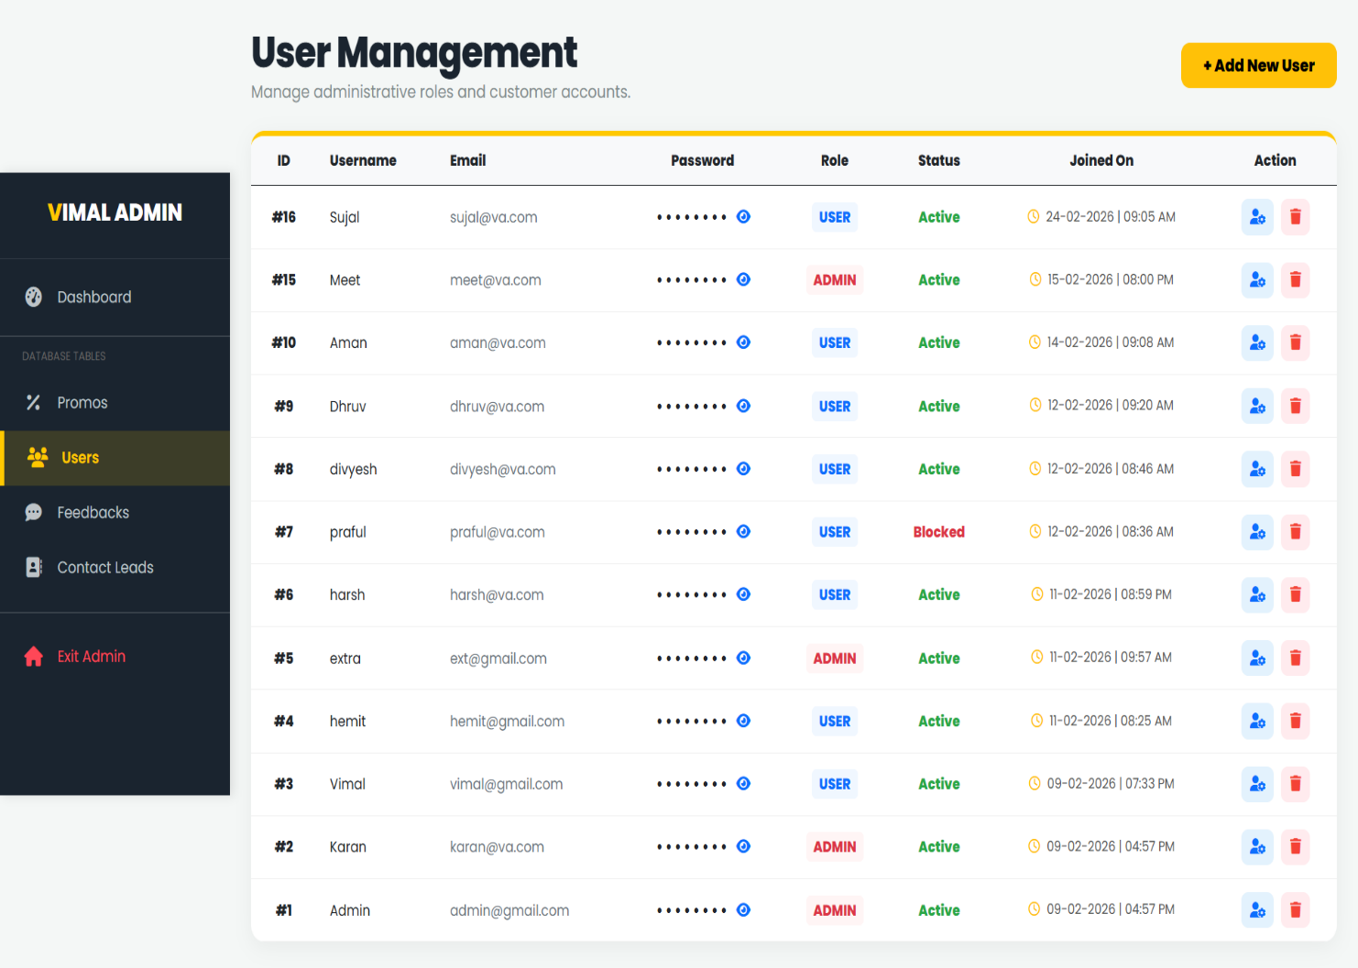

Description
This image displays the User Management page of the Vimal Agency Admin Panel, where the administrator can manage customer and admin accounts.

User Management Overview
At the top, the page title reads:
“User Management”
Below it, a subtitle states:
“Manage administrative roles and customer accounts.”
On the right side, a prominent yellow button labeled “+ Add New User” is provided to create a new account.

Users Table Structure
The page contains a structured table with the following columns:
- ID – Unique user identification number
- Username – Name of the user
- Email – Registered email address
- Password – Masked password (hidden with dots)
- Role – USER or ADMIN
- Status – Account status (Active / Blocked)
- Joined On – Registration date and time
- Action – Role change and Delete buttons

Role Types
Two types of roles are displayed:
- 🔵 USER – Regular customer account
- 🔴 ADMIN – Administrative account with system control access
This helps differentiate between customer and system-level users.

Status Indicators
- 🟢 Active – User account is active
- 🔴 Blocked – User account is restricted
This allows the admin to control system access.

Action Controls
Each user row includes:
- 👤 Role/Permission Button – To manage or modify user role
- 🗑 Delete Button – To remove user account
This enables complete user management functionality.

8. Manage User Feedback Page
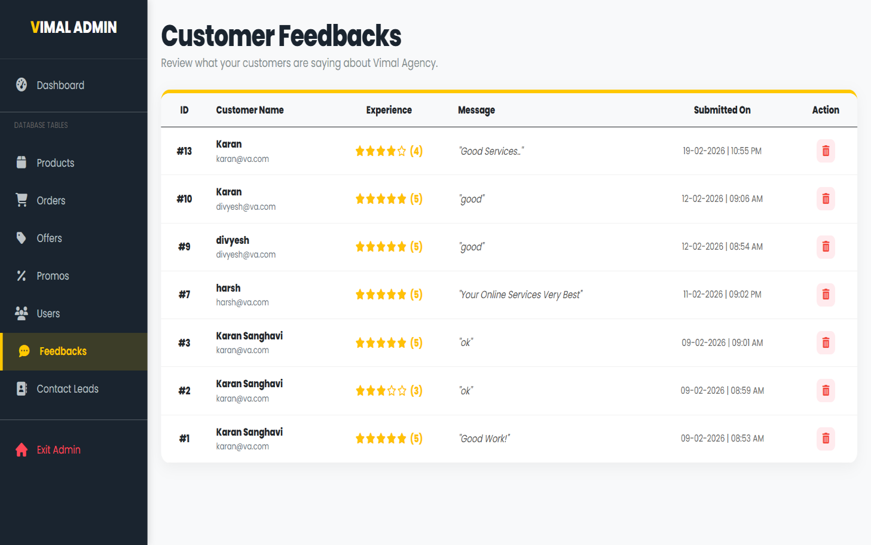

Description
This image displays the Customer Feedbacks page of the Vimal Agency Admin Panel, where the administrator can review and manage customer feedback submissions.

Customer Feedback Overview
At the top, the page title reads:
“Customer Feedbacks”
Below it, a subtitle states:
“Review what your customers are saying about Vimal Agency.”
This indicates that the page is dedicated to monitoring customer satisfaction and reviews.

Feedback Table Structure
The page contains a structured table with the following columns:
- ID – Unique feedback identification number
- Customer Name – Name and email of the customer
- Experience – Star rating (e.g., ★★★★☆ (4), ★★★★★ (5))
- Message – Customer’s written feedback
- Submitted On – Date and time of submission
- Action – Delete button

Rating System
The feedback includes a visual star rating system:
- ⭐⭐⭐⭐⭐ (5) – Excellent
- ⭐⭐⭐⭐ (4) – Very Good
- ⭐⭐⭐ (3) – Average
This helps the admin quickly understand overall customer experience.

Action Controls
Each feedback entry includes:
- 🗑 Delete Button – To remove inappropriate or unnecessary feedback
This provides moderation control to the administrator.

9. Manage Contact Lead Page
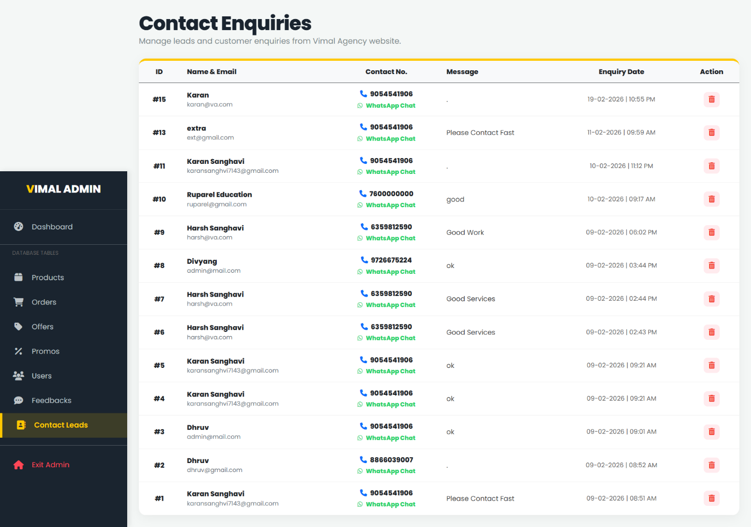

Description
This image displays the Contact Enquiries (Contact Leads) page of the Vimal Agency Admin Panel, where the administrator can manage customer inquiries submitted through the website.

Contact Enquiries Overview
At the top, the page title reads:
“Contact Enquiries”
Below it, a subtitle states:
“Manage leads and customer enquiries from Vimal Agency website.”
This indicates that the page is dedicated to handling customer communication and business leads.

Enquiries Table Structure
The page contains a structured table with the following columns:
- ID – Unique enquiry identification number
- Name & Email – Customer name and registered email address
- Contact No. – Customer phone number
- Message – Customer inquiry or message content
- Enquiry Date – Date and time of submission
- Action – Delete button

Contact Options
Each enquiry row includes:
- 📞 Phone Number – Direct contact option
- 💬 WhatsApp Chat Link – Quick communication via WhatsApp
This allows the admin to respond to customers quickly and efficiently.

Action Controls
Each enquiry entry includes:
- 🗑 Delete Button – To remove resolved or unnecessary enquiries
This helps maintain clean and organized lead records.

CODING (FEW CODE SNIPPETS)

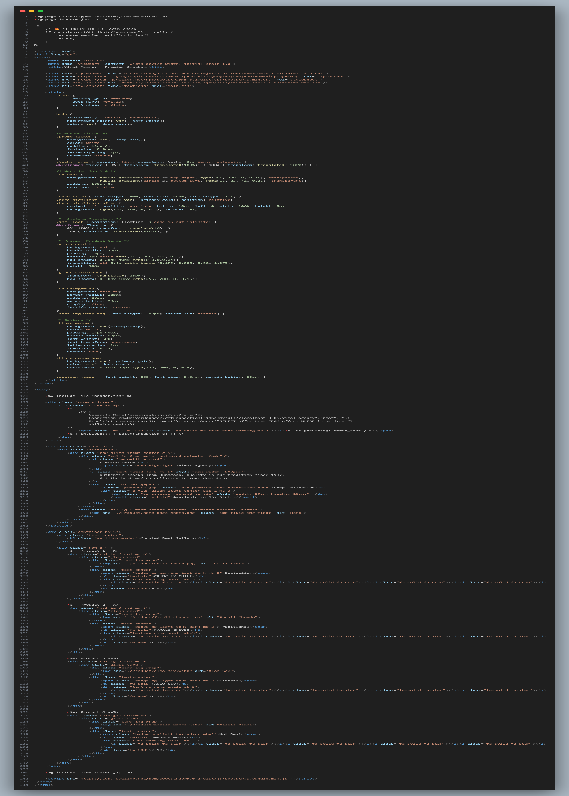
1. Index Page

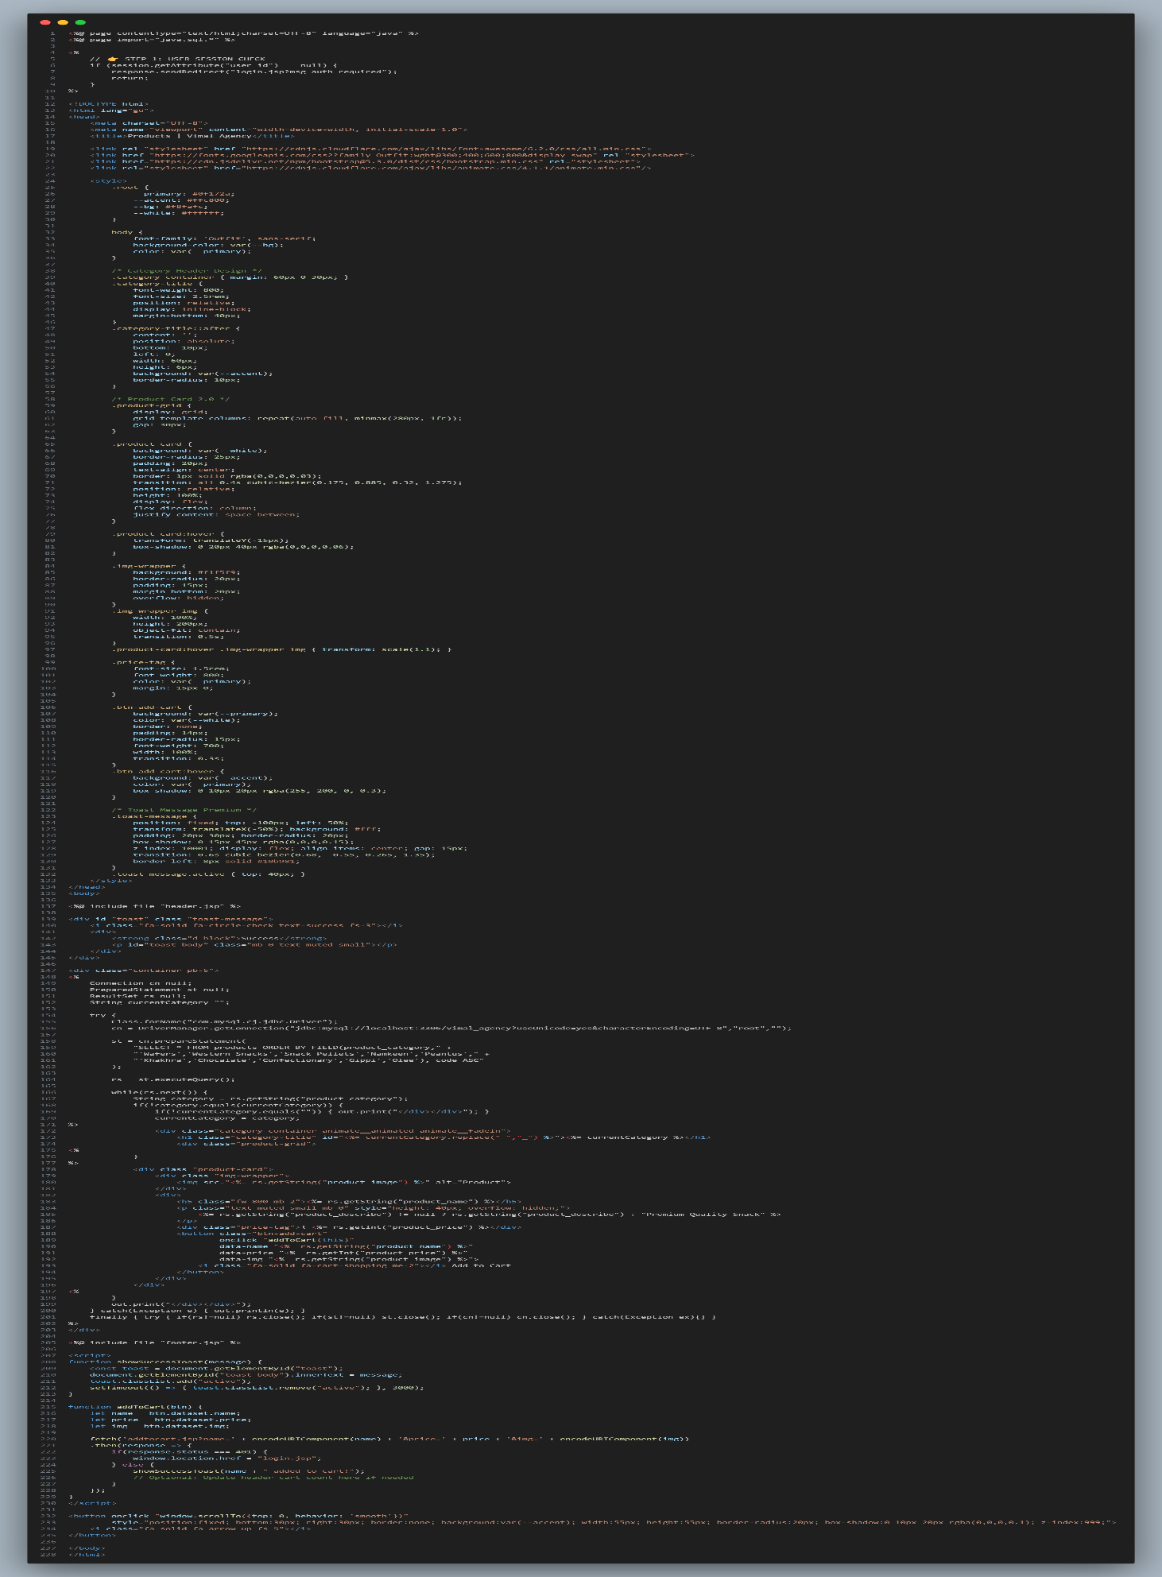
2. Product Page

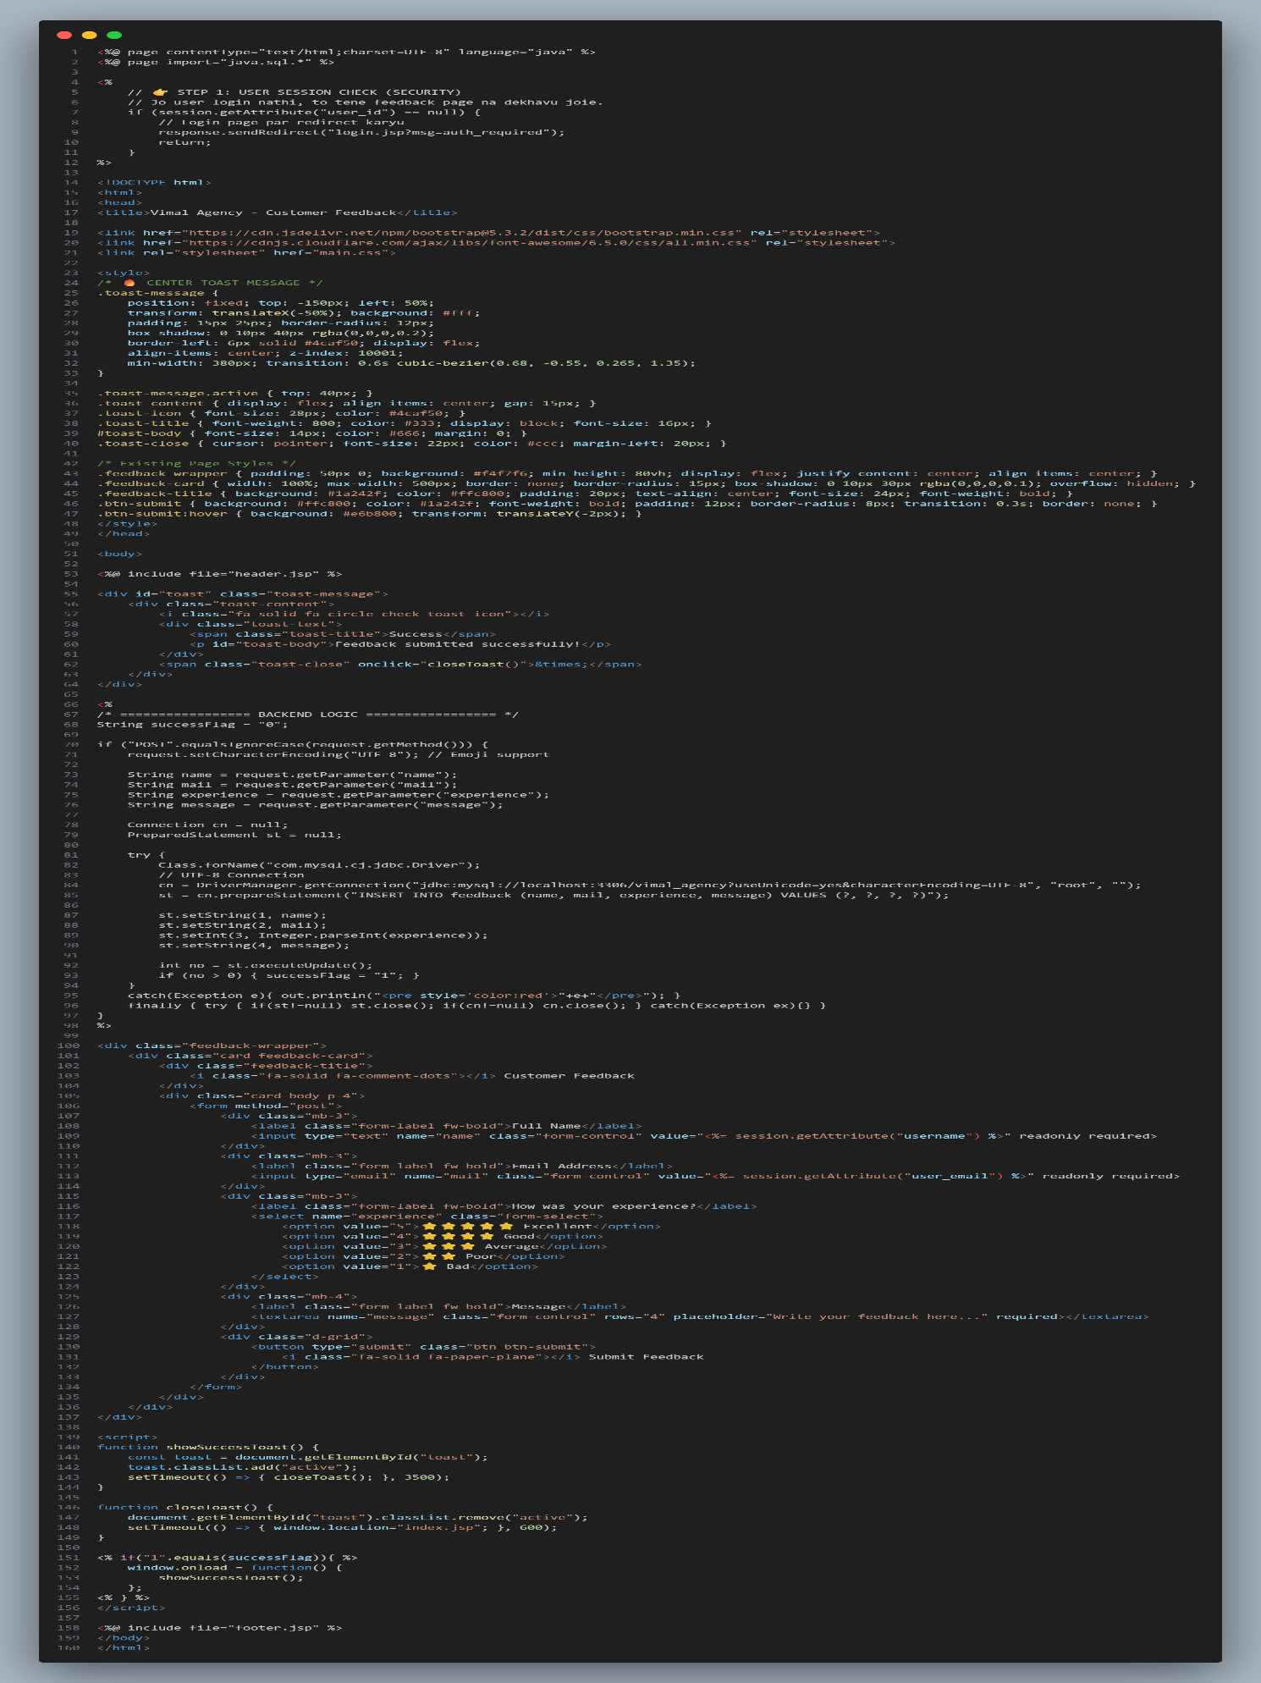
3. Feedback Page

TESTING (MANUAL, TEST CASE)

6.1 Manual Testing

Manual Testing :-
Manual testing for Vimal Agency ensures that the system properly supports real-world wholesale and distribution operations such as order handling, billing, stock management, and account tracking.
In this process, human testers use the software like actual users (Admin, Salesman, Accountant) to identify errors, usability issues, and logical problems that automated testing may not detect.

Testing Strategies :-
• Black Box Testing:
Testing the application without checking the internal code. Focus is on inputs and outputs.
Example: When adding a new product (like biscuits or snacks), the system should correctly display it in the product list and allow it to be added in billing.
• Functional Testing:
Verifying that all core features work properly such as:
- User Login & Logout
- Product Management
- Order Entry
- Billing & Invoice Generation
- Stock Update after Sales
- Backup & Restore Database
• Usability Testing:
Ensuring the interface is simple and easy to use for Vimal Agency staff.
Buttons, navigation menu, dropdowns, and reports should be clearly visible and user-friendly for daily business operations.

• Regression Testing:
After adding new features (like statement entry or report generation), previously working modules (like billing or stock update) are re-tested manually to ensure they are not affected.
6.2 Test Cases
Test cases are specific scenarios used to determine if a feature is working correctly. Below is a sample of high-priority test cases for the Vimal Agency system.

Test Case Suite :- Test ID | Module | Scenario | Expected Result
TC-01 | Authentication | Login with valid credentials. | User is redirected to the Dashboard.
TC-02 | Sales/Orders | Applying a 10% discount code to a bulk order. | Grand total should calculate as $Total - (Total \times 0.10) $.
TC-03 | Payment | Processing an order | Order should be "Pending Approval" or "Rejected."

ENHANCEMENTS

7.1 Advantages of Your Project

The Vimal Agency Billing & Inventory Management System is designed to bridge the gap between traditional wholesale distribution and modern digital business management.
• Centralized Data Management: Eliminates the manual register system by storing all customer, product, billing, and stock data in a single secure database.
• Real-time Inventory Tracking: Prevents over-selling or stock shortages by automatically updating stock levels immediately after bill generation.
• Automated Billing: Reduces human errors in calculations involving quantity, price, GST, and total amount by generating invoices automatically.
• Enhanced Reporting: Business owners can generate monthly sales reports and stock summaries instantly instead of manually checking ledger books.
• Role-Based Access Control (RBAC): Ensures system security by providing different access permissions to Admin, Staff, and Accountant users.

7.2 Limitations of Your Project

No system is perfect at launch. Identifying these limitations shows a realistic understanding of the Vimal Agency system’s current stage of development.
• Internet Dependency: Since the system runs on a web-based platform (JSP & MySQL), it requires a stable internet or local server connection. If connectivity fails, users cannot access the system.
• Initial Data Entry Effort: Shifting from manual registers to digital records requires one-time effort to enter existing product stock, customer details, and previous billing data.
• Hardware Requirements: Smooth performance requires a computer with updated browser and sufficient RAM. Older systems may experience slow processing.
• No Offline Mode: Currently, if the server stops or the system goes offline, billing and order entries cannot be stored locally for later synchronization.

7.3 Future Scope

The future roadmap of the Vimal Agency Billing & Inventory Management System aims to transform it from a basic management software into a smart and fully automated business solution.
• AI-Based Sales Prediction: By analyzing past sales data, the system can predict high-demand products during specific seasons or festivals, helping in better stock planning and purchase decisions.
• Mobile Application (Android/iOS): Developing a mobile app version of the system so that sales staff can generate bills, check stock, and manage orders directly from their smartphones.
• Online Payment Integration: Integrating UPI, Credit/Debit Cards, and Net Banking options to allow instant digital payments and automatic payment record updates.
• Multi-Language Support: Adding regional language options (such as Gujarati and Hindi) so that staff members can use the system comfortably.
• WhatsApp Integration: Automatically sending invoice PDFs, payment reminders, and order confirmations to customers via WhatsApp for faster communication.

Reference

1. Books:

• Murach's Java Servlets and JSP (3rd Ed)
• Head First Servlets and JSP
• JDBC 4.2, Servlet 3.1 & JSP 2.3 Black Book
• Professional Java Server Programming

2. Online Documentation & Learning Websites:

• Oracle Java EE Documentation
• W3Schools (Java Tutorial)
• chatgpt.com
• gemini.google.com

